6. THE BEAST OUT OF THE SEA.

The Incarnation Of "The Dragon," "The Anti-God."
In "The Beast" Or "Anti-Christ."
Rev. 13:1-10.
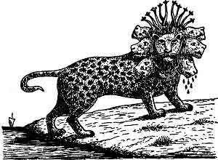
"And I (He, the Dragon, R. V.) stood upon the sand of the sea and (I) saw a 'BEAST' rise up out of the SEA having 'SEVEN HEADS' and 'TEN HORNS,' and upon his horns 'TEN CROWNS,' and upon his heads the name of BLASPHEMY. And the 'BEAST' which I saw was like a LEOPARD, and his feet were as the feet of a BEAR, and his mouth as the mouth of a LION: and the 'DRAGON' gave him his POWER, and his SEAT (Throne), and GREAT AUTHORITY. And I saw one of his HEADS as it were wounded to death: and his deadly wound was healed: and all the world wondered after the 'BEAST.' And they worshipped the 'DRAGON' which gave power unto the 'BEAST,' and they worshipped the 'BEAST,' saying, Who is like unto the 'BEAST'? Who is able to make war with him? And there was given unto him a mouth speaking great things and blasphemies; and power was given unto him to continue forty and two months. And he opened his mouth in blasphemy against God, to blaspheme His name, and His Tabernacle, and them that dwell in Heaven. And it was given unto him to make war with the saints, and to overcome them: and power was given him over all kindreds, and tongues, and nations. And all that dwell upon the earth shall WORSHIP HIM, whose names are not written in the 'BOOK OF LIFE' of the Lamb slain from the foundation of the world. If any man have an ear, let him hear. He that leadeth into captivity shall go into captivity: he that killeth with the sword must be killed with the sword. Here is the patience and the faith of the saints."
John next saw the "Dragon" standing on the seashore, and as he stood, a "Beast" rose up out of the sea having "SEVEN HEADS" and "TEN HORNS," and upon his "Horns" "TEN CROWNS," and upon his "Heads" the name of BLASPHEMY, and the body of the "Beast" was like a LEOPARD, and his feet were as the feet of a BEAR, and his mouth as the mouth of a LION, and the "DRAGON" gave him his POWER, and his SEAT (Throne), and GREAT AUTHORITY. This does not necessarily mean that the "Dragon" gave him his own throne, but he gave him power, and a throne, and great authority. As John was back on the Isle of Patmos, the "sea" from which he saw the "Beast" arise was probably the Mediterranean, though the "sea" in prophecy signifies the nations.
What does this "COMPOSITE BEAST" signify? This is not the first time we have read in the Scriptures of a "Beast" coming up out of the sea, so we must go back to the Book of Daniel for an explanation. While Daniel was a Statesman and did not hold the "Prophetic Office," he had the "Prophetic Gift," and was not only an interpreter of dreams, but a Prophet, and to him was revealed the whole course of the "Times of the Gentiles," and the character of its last "Great Leader" the "ANTICHRIST." His prophecy is mainly concerned with the things that shall befall his people, the Jews, in the "LATTER DAYS" (Dan. 10:14), and as we are now dealing with the things that shall come to pass in the "Last" or "Seventieth Week," of Daniel's "Seventy Weeks," we necessarily must turn back to the Book of Daniel for an explanation of this symbol of the "BEAST." But before we take .that up it is important to note that both the Old and New Testaments speak of a
"MYSTERIOUS AND TERRIBLE PERSONAGE"
who shall be revealed in the "Last Times." He is called by various names.
In The Old Testament
"The Assyrian."--Isaiah 10:5-6; 30:27-33.
"King of Babylon."--Isaiah 14:4.
"Lucifer."--Isaiah 14:12.
"The Little Horn."--Daniel 7:8; 8:9-12.
"A King Of Fierce Countenance."--Dan. 8:23.
"The Prince That Shall Come."--Dan. 9:26.
"The Wilful King."--Dan. 11:36.
In The New Testament
"The Man Of Sin."--2. Thess. 2:3-8.
"Son Of Perdition."--2. Thess. 2:3-8.
"That Wicked."--2. Thess. 2:3-8.
"Antichrist."--1. John 2:18.
"The Beast."--Rev. 13:1-2.
Jesus also made a prophetic reference to him. "I am come in my Father's Name, and ye receive me not; if another shall come in his own name, him ye will receive." John 5:43.

I. ISAIAH'S FOREVIEW.
The Prophet Isaiah sees the Antichrist as the "ASSYRIAN." Isa. 10:5, 12, 24; 30:27-33. In Isa. 11:4, a chapter which is evidently Messianic, we read that among other things which the Messiah will do--"He shall smite the earth with the 'rod of His mouth,' and with the 'breath of His lips' shall He slay 'THE WICKED'." The word translated "THE WICKED," is in the singular number, and cannot refer to wicked persons in general, but to some one person who is conspicuously wicked. The expression is strikingly like that of Paul's in 2. Thess. 2:8. "Then shall that 'WICKED' be revealed, whom the Lord shall consume with the 'Spirit of His Mouth,' and shall destroy with the 'Brightness of His Coming'." It is evident that Isaiah and Paul refer to the same individual, who can be no other than the Antichrist.
In Isa. 14:4-17 there is a description of a "King of Babylon" who shall smite the people in his wrath, and rule the nations in anger. He is called "LUCIFER, Son of the Morning," and his fall is described. He is cast down to Hell (Sheol, the Underworld), where his coming creates a great stir among the kings of the earth that have preceded him, and who exclaim when they see him--"Art thou .also become weak as we? Art thou become like unto us? . . . Is this the man that made the earth to tremble, that did shake kingdoms; that made the world as a wilderness and destroyed the cities thereof; that opened not the house of his prisoners?" There has never as yet been such a King of Babylon as is here described. It must therefore refer to some future King of Babylon, when Babylon shall be rebuilt, as we shall see it is to be. Verses 12 to 14 evidently refer to Satan, and are descriptive of him before his fall, but as he is to incarnate himself in the Antichrist, who is to be a future King of Babylon, it explains the source of the pride and presumption of Antichrist, which will lead to his downfall, as it did to Satan's.

II. DANIEL'S FOREVIEW.

1. The Colossus.
We now turn to Daniel. The Book of Daniel may be divided into two parts. The first six chapters are Historical, the last six are Prophetical. The Book contains one "Dream" by Nebuchadnezzar, and four "Visions" by Daniel, all relating to the "Times of the Gentiles." Nebuchadnezzar in his "Dream" saw a "Great Image" or "COLOSSUS." The Head of the "Image" was of fine gold, its Breast and Arms of silver, its Belly (Abdomen) and Thighs (Hips) of brass, its Legs of iron, and its Feet of iron and clay. This Image was destroyed by a "Stone" cut out of a mountain supernaturally. The "Stone" in turn became a great mountain and filled the WHOLE EARTH. Dan. 2:31-35. The four metals of which the "COLOSSUS" was composed represented Four Worldwide Empires which were to arise in succession. Dan. 2:37-40. Four great Empires, and only four, were to succeed each other in the government of the world, from Nebuchadnezzar (B. C. 606) to the "Second Coming" of Christ--the Babylonian, Medo-Persian, Grecian, and Roman. These Empires are not only made known as to number, but their names, in the order of their succession, are given. The First--"BABYLONIAN" is indicated by Daniel while interpreting the vision to Nebuchadnezzar. "THOU art this Head of Gold." Dan. 2:38. The Second--the "MEDO-PERSIAN," Daniel points out in his account of "Belshazzar's Feast," by the emphatic words--"In that night was Belshazzar the King of the Chaldeans slain, and Darius the MEDIAN took the Kingdom." Dan. 5:30-31. The Third--the "GRECIAN," is mentioned in Dan. 8:20-21, "the Ram which thou sawest having 'two horns' are the kings of Media and Persia, and the 'Rough Goat' is the King of Grecia (Greece)." The Fourth--the "ROMAN," is referred to in Dan. 9:26 as--"the PEOPLE of the 'Prince' that should destroy the city (Jerusalem) and the Sanctuary," and we know that it was the ROMANS under Titus, that destroyed Jerusalem in A. D. 70. While these Four Great Empires were to follow each other in the order named, they were not to follow without a break. The Babylonian lasted from B. C. 606 to B. C. 538. The Medo-Persian from B. C. 538 to B. C. 330. The Grecian from B. C. 330 to B. C. 323. Then the Grecian was broken up into four parts, Thrace, Macedonia, Syria, and Egypt, and the last of these was conquered by the Romans in B. C. 30, and the Roman Empire lasted from B. C. 30 to A. D. 364, when it was divided into its Eastern and Western Divisions. Since then there has been no leading world Empire, and cannot be according to this prophecy until Christ sets up His "STONE" or "Millennial Kingdom," as represented by the "Stone" that smites the "COLOSSUS" on its feet, for this "STONE KINGDOM" is to fill the whole earth, and thus be universal. This "STONE" cannot be Christianity, for it does not fill the earth by degrees, and thus crowd out the "COLOSSUS," but it at One Blow DEMOLISHES IT. The action of the "STONE" is that of JUDGMENT not Grace, and is SUDDEN and CALAMITOUS. Again the TIME of the destruction is not until after the formation of the Toes, and we know that the "TWO LIMBS" did not appear until A. D. 364, and the "TEN TOES" have not yet developed. The TIME when the "STONE" falls on the "FEET" we are told is "in the days of THOSE KINGS" (Dan. 2:44), that is the Kings represented by the "Ten Toes," which as we shall see corresponds with the "Ten Horns" of Daniel's "Fourth Wild Beast," Dan. 7:7-8, and with the "Ten Kings" of John's "Beast." Rev. 17:12. The first Four Kingdoms were literal Kingdoms, and so must the "Stone Kingdom" be, for it is to take the place of those Kingdoms and fill the whole earth. It represents therefore the "Millennial Kingdom" of Christ, for He is the "STONE" of the Scriptures. Matt. 21:44.
From what has been said we see that the "COLOSSUS" of "Nebuchadnezzar's Dream" symbolized the "World Kingdoms" in their Unity and Historical Succession. Gentile dominion is represented by a huge "METALLIC MAN." The degeneration of the "World Kingdoms" is seen in the diminishing value of the metals used. Silver is worth less than gold, brass than silver, iron than brass, and clay than iron. The weight of the "COLOSSUS" also declines; the specific gravity of gold is 19.5, of silver 10.47, of brass 8, of cast-iron 5, and of clay 1.93. The "Colossus" is TOP HEAVY. The character of the governing power also deteriorates from an "Absolute Monarchy" under Nebuchadnezzar, to an "Autocratic Democracy" symbolized by the mixture of the iron and clay of the Feet. In other words the governing power passes from the Head, the organ that ought to direct the members of the body, to the Feet, which are only made to carry the body whither the Head directs. We have dwelt thus at length on the "Colossus," for it is only as we understand it, that we can understand the meaning of the "Wild Beasts" that Daniel saw come up out of the sea.
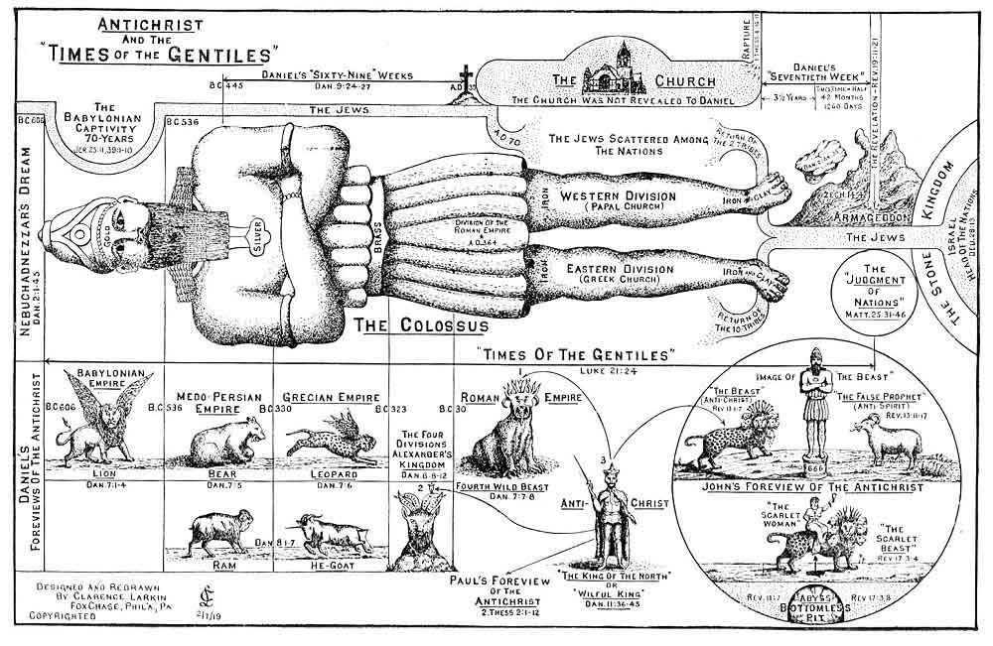Antichrist and the ''Times of the Gentiles''

2. The Vision of the "FOUR BEASTS."
Forty-eight years after Nebuchadnezzar had his "Dream," B. C. 555, Daniel in vision stood upon the shore of the "Great Sea" (the Mediterranean), and saw four "Great Beasts" come up out of the sea in succession.
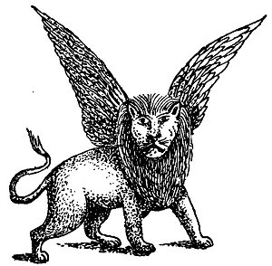
FIRST BEAST. The "First Beast" was like a LION and had Eagle's Wings, and as the Prophet watched it, he saw it lifted up from the earth, and made to stand upon its feet as a Man, and a Man's Heart was given to it. Dan. 7:4. We have only to visit the British Museum, London, and examine the Colossal Stone Lions with the "wings of an eagle" and the "head of a man," disinterred from the ruins of Babylon and Assyria by Sir Henry Layard between the years 1840 and 1850 A. D., to see that this "FIRST BEAST" stands for Babylon and its King--Nebuchadnezzar. The peculiarity of this "FIRST BEAST" was that it had "Eagle's Wings." This combination of the LION, the "King of Beasts," and the EAGLE, the "King of Birds," corresponded to the Royalty of the "Head of Gold" of the "COLOSSUS," and typified the "Eagle-like" swiftness of the armies of Nebuchadnezzar. The "Plucking of the Wings" doubtless referred to the "Beastly Insanity" of Nebuchadnezzar (Dan. 4:20-27), and the "lifting up," and causing to stand upon its feet "as a MAN," to his restoration to sanity.

SECOND BEAST. The "Second Beast" was "like to a BEAR, and it raised up itself on one side, and it had "Three Ribs" in the mouth of it, between the teeth of it: and they said thus unto it Arise, devour much flesh." Dan. 7:5. The bear is the strongest beast after the lion and is distinguished for its voracity, but it has none of the. agility and majesty of the lion, is awkward in its movements, and effects its purpose with comparative slowness, and by brute force and sheer strength. These were the characteristics of the Medo-Persian Empire. It was ponderous in its movements. It did not gain its victories by bravery or skill, but overwhelmed its enemies by hurling vast masses of troops upon them. Xerxes' expedition against Greece was undertaken with 2,500,000 fighting men, who with the camp followers made up an army of 5,000,000. Other Persian generals had armies running up into the 100,000's of men. It is easy to be seen that the movements of such enormous bodies of men would "devour much flesh," not only in the destruction of their enemies, but thousands would die of disease and exposure and the countries through which they passed would become famine-stricken by the loss of food seized to feed such armies. The side of the "BEAR" which raised up to attack signifies Persia, in which lay the greatest military strength, and corresponded to the "right shoulder and arm" of the "Colossus." The "Three Ribs" stood for the three Kingdoms of Lydia, Babylon and Egypt, which formed a "Triple Alliance" to check the Medo-Persian power, but were all destroyed by it.
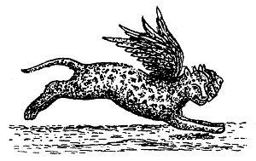
THIRD BEAST. The "Third Beast" was "like a LEOPARD, which had upon the back of it four wings of a fowl; the 'BEAST' had also four heads; and dominion was given to it." Dan. 7:6. The Leopard is the most agile and graceful of creatures; but its speed is here still further assisted by "wings." Slight in its frame, but strong, swift and fierce, its characteristics render it a fitting symbol of the rapid conquests of the Greeks under Alexander the Great, who, followed by small but well-equipped and splendidly brave armies, moved with great celerity and in about 10 years overthrew the unwieldy forces of Persia, and subdued the whole civilized world. The "four wings of a Fowl" indicate, that, as a "fowl" does not fly high, the armies of Alexander were fitted mainly for lowland fighting. There is an incongruity between the number of "wings" and the number of "heads" of the Leopard. "Four heads" call for "four pair of wings." Why only "four" wings we do not know, unless they denote the four quarters of the earth into which Alexander sought to extend his Kingdom.
The "Four Heads" of the LEOPARD represent the "Four Kingdoms" into which the Empire of Alexander was divided by his generals, namely Thrace, Macedonia, Syria and Egypt. The "Third Beast" corresponds to the "Abdomen" and "Hips" of the "COLOSSUS."
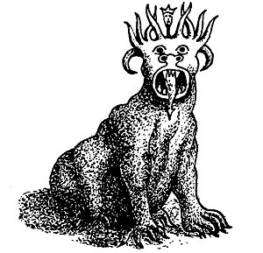
FOURTH BEAST. The "Fourth Beast" was unlike any Beast that Daniel had ever seen or heard about. It was "dreadful and terrible, and strong exceedingly, and it had great IRON TEETH. It devoured and brake in pieces, and stamped the residue (the other Beasts) with the feet of it; and it was diverse from all the 'BEASTS' that were before it, and it had 'TEN HORNS'." Dan. 7:7. The fact that the "Fourth Beast" had "Iron Teeth," and that there were "Ten Horns" on its Head, the "iron" corresponding to the "Iron Limbs," and the "Ten Horns" to the "Ten Toes" of the "COLOSSUS," would cause Daniel to see that the "Fourth Beast" stood for the Fourth World Empire, the ROMAN.
But as Daniel "considered" the "Ten Horns," he was amazed to see another "Horn," a LITTLE one, come up among them, and before whom there were "three" of the "First Horns" plucked up by the roots, that is destroyed. And as he examined the "LITTLE HORN" more closely he noticed that it had Eyes like the eyes of a Man, and the Mouth of a Man speaking great things. Dan. 7:8. This mystified and troubled Daniel. He had seen nothing corresponding to it on the "Ten Toes" of the "COLOSSUS." It must mean some new and additional revelation that God had not seen fit to impart to the Gentile King Nebuchadnezzar, and that was reserved for Daniel and his people (the Jews), for we must not forget that Daniel's own visions, in the last six chapters' of the Book, have to do with God's dealings with the Jewish People in the "LATTER DAYS." Dan. 10:14. So Daniel approached one of the "Heavenly Messengers" that stood by and asked him the meaning of what he had seen. He was told that the "Four Beasts" stood for "FOUR KINGS" or "KINGDOMS" (vs. 23), that should arise out of the earth. Then Daniel wanted to know the "truth" about the "FOURTH Beast," which was so diverse from the other three, and particularly about the "LITTLE HORN" that came up among the "Ten Horns" on its head. In explanation Daniel was told that the "Ten Horns" on the "Fourth Beast" represented "TEN KINGS" that shall arise, and that the "Little Horn" was a "King" that should rise among them and subdue three of them, and that he would be a "PERSON" of remarkable intelligence and great oratorical powers, having a mouth speaking great things. That he would be audacious, arrogant, imperious, and persecuting, and change "times and laws," and that the "Saints of the Most High" (Daniel's People) would be given into his hands for a "Time, and Times, and the Dividing of Time," or 3½ years.
In this Vision of the "Four Beasts" we see "Degeneration" just as we saw it in the metals of the "COLOSSUS." The descent is from the LION, the "King of Beasts," to a nondescript "MONSTER" that defies description. The reason why these "Four Kingdoms" are rep-resented first as a "Golden Headed Metallic Image," and then as a succession of "Wild Beasts," is to show the difference between Man's view and GOD'S view of the World Kingdoms. Man sees in them the concentration of wealth, majesty and power; GOD sees them as a succession of rapacious Wild Beasts devouring one another.


3. The Vision Of The "RAM" And The "HE-GOAT."
The explanation as to the meaning of the "LITTLE HORN" perplexed Daniel, and he voiced it by saying "My 'cogitations' much troubled me, and my countenance changed in me (he had a sad look); but I kept the matter in my heart." Dan. 7:28. To comfort His Servant, God, two years later, transported Daniel in vision to Shushan, the Capital of Persia, and as he stood on the bank of the river Ulai, he saw a RAM which had "Two Horns," one higher than the other, and the higher came up last. He saw the RAM push "Westward," and "Northward," and "Southward," and nothing could stand before it, and it did according to its will. Dan. 8:4. While Daniel was "considering" what the Vision of the RAM meant, he saw a HE-GOAT come from the West unmolested, and he noticed it had a "NOTABLE HORN" between its eyes, and when it reached the RAM it was moved with "choler" or anger against it, and smote it with "fury," and broke its. "Two Horns," and knocked it down and stamped upon it. Then the HE-GOAT waxed great, but when it became strong its "GREAT HORN" was broken off, and "Four Notable Horns" came up in its place, and out of one of them sprang a "LITTLE HORN" which waxed exceedingly great toward the "South," and toward the "East," and toward the "Pleasant Land" (Palestine), Dan. 8; 5-9.

When Daniel sought for the meaning of this Vision he heard a voice say--"Gabriel, make this man to understand the Vision." Then Gabriel said to Daniel the Vision belongs to the "Time of the End" (the End of the Times of the Gentiles), and is to make thee know what shall come to pass in the "Last End of the Indignation" (the Great Tribulation). Dan. 8:15-19. Gabriel then informed Daniel that the "RAM" stood for the "Medo-Persian Empire," with its two Kings, Darius and his nephew Cyrus, that the "HE-GOAT" stood for the "Grecian Empire," the "GREAT HORN" between its eyes for its first King (Alexander the Great), and that the "FOUR HORNS" that took the place of the "GREAT HORN," stood for "Four Kingdoms" into which the "Grecian Empire" should be divided.
This explanation cleared up things considerably for Daniel. It revealed to him that the "TWO HORNS" of the RAM, one higher than the other, and the "TWO SHOULDERS" of the BEAR, one higher than the other, and the "TWO ARMS" of the COLOSSUS, stood for the same thing, the double Empire of Medo-Persia. He also saw that the "FOUR HORNS" that came up in the place of the "GREAT HORN" corresponded to the "FOUR HEADS" of the LEOPARD, and therefore must correspond with the "ABDOMEN" and "HIPS" of the COLOSSUS, and stand for the Grecian Empire, and its "Fourfold Division" among the Generals of Alexander the Great.
But Daniel was still troubled as to the meaning of the "LITTLE HORN" that he saw come out of one of the "Four Horns" of the HE-GOAT, and Gabriel told him that it stood for a King of "Fierce Countenance" who should stand up in the "LATTER TIME" of the Kingdom, and who should stand up against the "PRINCE OF PRINCES" (Christ). Dan. 8:23-25. The description of this "LITTLE HORN" so clearly corresponded to the description of the "LITTLE HORN" that Daniel saw arise amid the "Ten Horns" of the "Fourth Wild Beast," that he saw they described and stood for the same Person. The revelation so overcame Daniel that he "fainted," and was sick certain days. Dan. 8:27

4. The Vision Of The "KINGS OF THE NORTH AND SOUTH."
While Daniel had revealed to him that the "LITTLE HORN" should come out of one of the "Four Kingdoms" into which the Empire of Alexander the Great was divided, he was not at that time told which one, but 20 years later, in B. C. 533, the information was imparted to him in a Fourth Vision. He saw in vision two Kings warring against each other. One was called the "King of the North," the other the "King of the South." This chapter (Dan. 11:1-45) is one of the most wonderfully minute as to prophetic details of any chapter in the Bible. It corresponds exactly with the profane history of the kings of Egypt and Syria for over 350 years. From verse 5 to verse 31 we have an account of what is called the "wars" of the "Kings of the North" (Syria) and of the "Kings of the South" (Egypt). These end with the close of the reign of Antiochus Epiphanes,
B. C. 164. Verses 32-35 cover the whole period from B. C. 164 down to the "Time of the End," that is, until the "Seventieth Week" of Daniel's "Seventy Weeks." At verse 36 the "WILFUL KING" appears, and from that verse down until the end of the Book of Daniel we have an account of what is to befall Daniel's People in the "Latter Days." As the description of the "WILFUL KING" corresponded with the description of the "LITTLE HORN" of the "Fourth Wild Beast" and the "LITTLE HORN" of the "He-Goat," and they were all to appear at the same time--the "Time of the End." Daniel understood that they referred to one and the same Person, and as the "WILFUL KING" would be the "King of the NORTH," that is, of Syria, Daniel saw that the "LITTLE HORN" was to rise on the "SYRIAN HORN" of the "He-Goat," in other words that the "LITTLE HORN," or "Antichrist," shall come out of SYRIA, and as Syria included Assyria that the "LITTLE HORN" of Daniel is the same as the "Assyrian" of Isaiah. "When the Lord hath performed His whole work upon Mount Zion and on Jerusalem (which will not be until Christ comes back), I will punish the fruit of the stout heart of the KING OF ASSYRIA (Antichrist) and the glory of his high looks." Isa. 10:12. I will break the ASSYRIAN (Antichrist) in My Land (Palestine), and upon My mountains tread him under foot; then shall his yoke depart from off them (Israel), and his burden from off their shoulders." Isa. 14:25. The context shows that this prophecy is connected with the restoration of Israel to their own land, not after the Babylonian Captivity, but a restoration that is still future, for the Assyrian Empire had been swallowed up by the Babylonian when the Prophet wrote and the ASSYRIAN King here mentioned must be some future Assyrian King, for he is to be brought to Palestine and destroyed there.
We must not allow ourselves to be confused by the different names given the Antichrist, as the "King of Tyrus," the "King of Babylon," and the "King of Assyria," for that section of the world will comprise one territory in the days of the Antichrist and he will be known by all of these titles.
From what we have thus far learned of the Antichrist, the probability is that he will be a SYRIAN JEW, for it is not likely that the Jews will accept as their Messiah one who is not a Jew, unless the claimant by false pretense makes them believe he is one. This, however, does not prevent the Antichrist being a Roman citizen, and the political head of the revived Roman Empire, for Saul of Tarsus was both a Jew and a Roman citizen.
Those who claim that the "LITTLE HORN" of Dan. 7, and the "LITTLE HORN" of Dan. 8, are not the same, because the "LITTLE HORN" of Dan. 7 arises amid the "Ten Horns" of the "Fourth Wild Beast," which represents the Roman Empire, and the "LITTLE HORN" of Dan. 8, arises on one of the Horns of the "He-Goat" which represents the Grecian Empire, and corresponds to the "Third Wild Beast," forget that the Vision that the Apostle John had of the revived Roman Empire (Rev. 13:1-2), the Roman Empire in its last stage, reveals the fact that the "last stage" of the Roman Empire will include all the characteristics of the whole Four Empires, Babylonian,
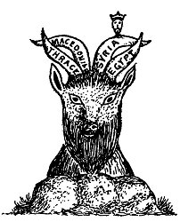
Medo-Persian, Grecian and old Roman. This is seen in the character of the "BEAST" John saw come up out of the sea. It was like unto a LEOPARD (Greece), with the feet of a BEAR (Medo-Persia), and the mouth of a LION (Babylon). The fact that the BODY of the "BEAST" was like a LEOPARD (Greece), reveals the fact that the preponderating feature of the revived Roman Empire will be GRECIAN, and that therefore the "Ten Federated Kingdoms," represented by the "Ten Horns" of the "Beast," will include the FOUR KINGDOMS into which the GRECIAN Empire was divided, viz., Egypt, Macedon, Thrace and SYRIA. It follows therefore that the "LITTLE HORN" of the "He-Goat" (Greece), will be the LITTLE HORN that rises among the "Ten Horns" of the "Fourth Wild Beast" (Rome), for Syria, one of the four divisions of the Grecian Empire, will be one of the component parts of the Revived Roman Empire.
Again those who claim that Antiochus Epiphanes (B. C. 175-165), a king of Syria, was the LITTLE HORN" of the "He-Goat," overlook the fact, that, while Antiochus Epiphanes devastated Palestine and caused an "idol altar" to be erected on the Brazen Altar of the Temple, on which he offered swine-flesh, which was an abomination to the Jews, he does not fulfil the description of the "LITTLE HORN" of the "He-Goat" (Dan. 8:9-12, 23-25), for Antiochus Epiphanes, nor any other ruler of the past, ever stood up against JESUS, the "Prince of Princes." Neither was Antiochus Epiphanes "broken without hand." He died a natural death at Tabae in B. C. 165. But the "LITTLE HORN" of the "He-Goat" is to be "broken without hand." His Kingdom is to be destroyed by a "stone cut out of the mountain WITHOUT HANDS," and he himself shall be "paralyzed" by the "brightness of the Lord's Coming" (1. Thess. 2:8), and he shall be cast ALIVE into the "Lake of even to be regarded as a "type" of Antichrist. They are distinct historical personages, and though they resemble each other in some respects, yet they must not be confounded with each other. After this prolonged exposition of Daniel's "Foreview" of the Antichrist, which has seemed necessary to a proper understanding of the meaning of the "Beast" which John saw come up out of the sea, we now turn to

III. PAUL'S FOREVIEW.
"Let no man deceive you by any means: for 'that Day' (the Day of the Lord) shall not come except there come a 'falling away first,' and that 'MAN OF SIN' be revealed. The
'SON OF PERDITION,'
who opposeth and exalteth himself above all that is called God, or that is worshipped; so that he As God sitteth in the Temple of God (the rebuilt Temple at Jerusalem), showing himself that he is God . . . For the
'MYSTERY OF INIQUITY'
doth already work (in Paul's day); only He (the Holy Spirit) who now letteth (restraineth R. V.) will let (restrain), until He be taken out of the way. And then shall
'THAT WICKED'
be revealed, whom the Lord shall consume with the spirit (breath) of His mouth, and shall destroy with the brightness (manifestation R. V.) of His Coming. Even him, whose coming is after the working of Satan with all power and signs and lying wonders, and with all deceivableness of unrighteousness in them that perish; because they received not the love of the truth (Christ) that they might be saved." 2. Thess. 2:3-10.
In the American Standard Edition of the Bible the Antichrist is called the "MYSTERY OF LAWLESSNESS" or the "LAWLESS ONE." As such he is not the cause of Lawlessness, he is the result or fruit of it, for he will arise out of the seething cauldron of Lawlessness that is now becoming more pronounced and manifest in the world.
The name that the Apostle Paul gives the Antichrist--the "SON OF PERDITION," is not without significance. The name is used but twice in the Scriptures. It is first used by Christ of Judas (John 17:12), and then here of Antichrist. The Apostle also calls the Antichrist in this passage the "MYSTERY OF INIQUITY." What does that mean? In 1. Tim. 3:16 Christ is spoken of as the "MYSTERY OF GODLINESS," that is, that He was God MANIFEST IN THE FLESH. How did He become "manifest in the flesh"? By being born of the Virgin Mary by the Holy Spirit. Thus it was that Jesus became the SON OF GOD. Luke 1:35. Now as iniquity is the opposite of godliness, then the "MYSTERY OF INIQUITY" must be the opposite of the "MYSTERY OF GODLINESS." That is, if Christ is the "MYSTERY OF GODLINESS," Antichrist must be the "MYSTERY OF INIQUITY," and as Christ was the "Son of God," then Antichrist must be the "SON OF PERDITION," that is, of SATAN. And as Christ was born of a virgin by the Holy Spirit, so Antichrist will be born of a woman (not necessarily a virgin) by Satan. This is no new view for it has been held by many of God's spiritually minded children since the days of the Apostle John, and there is some warrant for it in the Scriptures. In Gen. 3:15, God said to the Serpent (Satan), "I will put enmity between thee and the woman, and between 'THY SEED' and 'HER SEED'." Now the Woman's SEED was CHRIST, then the Serpent's SEED must be ANTICHRIST. In John 8:44 Jesus said to the Jews--"Ye are of your father THE DEVIL . . When he speaketh a lie, he speaketh of his own; for he is a liar, and the father of IT." In the Greek there is the definite article before "lie," and it should read "THE LIE," so when the Devil speaks of "THE LIE," he is speaking of his own (child), for he is a liar, and the FATHER OF "IT"--"THE LIE." And it is worthy of note that in the verse (vs. 11) that follows the passage we are considering that the Apostle says--"And for this cause God shall send them strong delusion that they should believe a lie." Here again the definite article is found in the Greek, and it should read "The LIE," the "SON OF PERDITION," the ANTICHRIST.
But why was Judas called the "SON OF PERDITION"? Was he a child of Satan by some woman, or was he simply indwelt by Satan? Here we must let the Scriptures speak for themselves. In John 6:70-71 we read that Jesus said "Have not I chosen you Twelve, and one of you is a DEVIL? He spake of Judas Iscariot the son of Simon; for he it was that should betray Him, being one of the Twelve." In no other passage than this is the word "Devil" applied to anyone but to Satan himself. Here the word is "diabolus," the definite article is employed, and it should read--"and one of you is THE DEVIL." This would make Judas the Devil incarnate, or the "MYSTERY OF INIQUITY," and explains why Jesus in John 17:12, calls him the "SON OF PERDITION."
This is the only place in the Scriptures where the word "diabolus" is applied to a human being, and it implies an incarnation.
While "Perdition" is a PLACE (Rev. 17:8, 11), it is also a "condition" into which men may fall (1. Tim. 6:9; Heb. 10:39), and while men who have committed the "Unpardonable Sin" are "sons of perdition," because they are destined to the place of the irrevocably lost, yet Judas and Antichrist are the "SONS OF PERDITION" in a special sense, for they are the SONS of the author of "Perdition"--THE DEVIL. That is they are not merely "obsessed" or controlled by the Devil, the Devil has incarnated himself in them, and for the time being, to all practical purposes, they are the very Devil himself.
The next question that arises is, "If Judas and the Antichrist are both called the 'SON OF PERDITION,' are they one and the same, or are there two 'Sons of Perdition'?" Here we must anticipate. Turning to Rev. 11:7, we read that the "Beast" that slays the "Two Witnesses" ascends out of the "Bottomless Pit" (ABYSS), and that "Beast" is the ANTICHRIST. Now how did he get into the "ABYSS"? Well, if there is only one "SON OF PERDITION," and Judas and Antichrist are one and the same, then he got in the ABYSS when Judas went to his "Own Place" (the ABYSS). Acts 1:25. Of no other person is it said anywhere in the Scriptures that he went "to his own place." Again in Rev. 17:8 it is said--"The 'Beast' that thou sawest was, and is not: and shall ascend out of the 'Bottomless Pit' (Abyss), and go into PERDITION." As this "Beast" is the same that slays the "Two Witnesses" he is the ANTI-CHRIST. Now there are four things said of him. First, he "WAS." Second, he "IS NOT." Third, he shall "ASCEND OUT OF THE BOTTOMLESS PIT." Fourth, he shall "GO INTO PERDITION." From this we learn that in John's day the "Beast" "Was Not," but that he had been before on the earth, and was to come again, that he was to ASCEND FROM THE BOTTOMLESS PIT. This is positive proof that the ANTICHRIST has been on the earth before, and that when he comes in the future he will come from the "ABYSS."
The question then arises, when was "Antichrist" on the earth before? If Judas and Antichrist are one and the same the enigma is solved. When Judas was on the earth, he WAS; when Judas went to his "Own Place" he "WAS NOT"; when Judas comes back from the "Abyss" he will be--THE ANTICHRIST. The Author does not insist on this view of Judas and Antichrist being correct, but with open mind he accepts it, because it seems to be the only logical solution of both Judas and Antichrist being called the "SON OF PERDITION."

IV. JOHN'S FOREVIEW.
"John saw "A 'BEAST' rise up out of the sea, having 'SEVEN HEADS' and 'TEN HORNS,' and upon his horns 'TEN CROWNS,' and upon his heads the name of BLASPHEMY. And the 'BEAST' which I saw was like a LEOPARD, and his feet were as the feet of a BEAR, and his mouth as the mouth of a LION: and the 'DRAGON' gave him his POWER, and his SEAT (Throne), and GREAT AUTHORITY. And I saw one of his HEADS as it were wounded to death: and his deadly wound was healed: and all the world wondered after the 'BEAST.' And they worshipped the 'DRAGON' which gave power unto the 'BEAST,' and they worshipped the 'BEAST,' saying, who is like unto the 'BEAST'? Who is able to make war with him? And there was given unto him a mouth speaking great things and blasphemies; and power was given unto him to continue forty and two months."
When we compare these "Foreviews," and note the similarity of conduct of Daniel's "LITTLE HORN," Paul's "MAN OF SIN," and John's "BEAST," and that Daniel's "LITTLE HORN" and John's "BEAST" are to continue for the same length of time--"Forty and Two Months," or 3½ years, and that Daniel's "LITTLE HORN," Paul's "MAN OF SIN," and John's "BEAST," are all to be destroyed in the same manner at Christ's "Second Coming," we see that they all prefigure the same "Evil Power," which is after the "Working of Satan," and which John in 1. John 2:18, calls THE ANTICHRIST. In other words when we find in prophecy "Three Symbolic Personages" that come upon the stage of action at the same time, occupy the same territory, exhibit the same character, do the same work, exist the same length of time, and meet the same fate, they must symbolize the SAME THING.
Before we examine in detail John's "BEAST," it would be well for us to compare it with Daniel's "FOURTH WILD BEAST."
Daniel's  Fourth Wild Beast  Dan. 7:7, 8, 19, 20, 23-25.  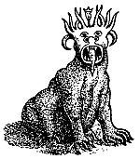  "After this I saw in the night visions, and behold a FOURTH BEAST, dreadful and terrible, and strong exceedingly; and it had great iron teeth; it devoured and brake in pieces, and stamped the residue (the 3 preceding Beasts) with the feet of it; and it was diverse from all the Beasts that were before it; and it had TEN HORNS. I considered the HORNS, and, behold, there came up among them another LITTLE HORN, before whom there were THREE of the FIRST HORNS plucked up by the roots; and, behold, in THIS HORN were eyes like the eyes of a MAN, and a mouth speaking great things."  "Then I would know the truth of the FOURTH BEAST, which was diverse from all the others, exceeding dreadful, whose teeth were of iron, and his nails of brass; which devoured, brake in pieces, and stamped the residue with his feet; and of the TEN HORNS that were in his head, and of the OTHER which came up, and before whom three fell; even of THAT HORN that had eyes, and a mouth that spake very great things, whose look was more stout than his fellows."  "Thus he said, the FOURTH BEAST shall be the FOURTH KINGDOM upon earth, which shall be diverse from all kingdoms, and shall devour the whole earth, and shall tread it down and break it in pieces. And the TEN HORNS out of this Kingdom are TEN KINGS that shall arise; and another (King) shall rise after them; and he shall be diverse from the first, and he shall subdue THREE KINGS. And he shall speak great words against the Most High, and shall wear out the saints of the Most High, and think to change times and laws; and they shall be given into his hand until a TIME and TIMES and the DIVIDING OF TIME." | John's  Beast Out Of The Sea  Rev. 13:1-7  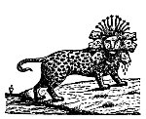  "I saw a BEAST rise up out of the SEA, having SEVEN HEADS and TEN HORNS, and upon his horns TEN CROWNS, and upon his heads the NAMES OF BLASPHEMY. And the BEAST which I saw was like unto a LEOPARD, and his feet were as the feet of a BEAR, and his mouth as the mouth of a LION; and the Dragon gave him his power, and his seat, and great authority. And I saw one of his HEADS as it were wounded to death; and his deadly wound was healed; and all the world wondered after the BEAST. . . . And there was given unto him a mouth speaking great things and blasphemies; and power was given unto him to continue FORTY AND TWO MONTHS. And he opened his mouth in blasphemy against God, to blaspheme His Name, and His Tabernacle, and them that dwell in Heaven. And it was given unto him to make war with the saints, and to overcome them; and power was given him over all kindreds, and tongues, and nations."
In comparing these two "BEASTS" we find that they both come up out of the sea (the nations), and that they are utterly unlike any beast we have ever heard of. Daniel's "Beast" was dreadful and terrible, and strong exceedingly; and it had great iron teeth, and nails of brass; while John's "Beast" was like a LEOPARD, with the feet of a BEAR, and the mouth of a LION. As Daniel's "Beast" represented the "FOURTH KINGDOM" upon the earth, the Roman Empire, it is evident that its characteristics describe the old Roman Empire, while the characteristics of John's Beast represent the revived Roman Empire. We know that the Old Roman Empire was "strong exceedingly" and its grip and power were like a beast with "great iron teeth" and "nails of brass," and from the description of John's "Beast" we learn that the revived Roman Empire shall embody all the characteristics of the Four World Empires, as seen in its LEOPARD like body, its feet of a BEAR, and its mouth of a LION. That both "Beasts" have TEN HORNS reveals the fact that they will be in existence at the time indicated by the TEN TOES of the Colossus, with which they correspond, which will be just before the setting up of the "Stone" or Millennial Kingdom of Christ. We are told that the "TEN HORNS" of Daniel's "Beast" stand for "TEN KINGS," and the "TEN HORNS" of John's "Beast" stand for the same. Rev. 17:12. From this we see that both Daniel and John foresaw that the Roman Empire was to be eventually divided into "Ten Separate but Federated Kingdoms."
While both "Beasts" have TEN HORNS, they differ in that John's had "SEVEN HEADS" while Daniel's had but ONE, and among the "TEN HORNS" on Daniel's "Beast" there came up a "LITTLE HORN," which is not seen amid the "TEN HORNS" of John's Beast. These, as we shall see, are features that refer to the last stage of the "Beast" and show that we cannot 'understand the last stage of the "Beast" without carefully comparing Daniel's and John's "Beasts," for the "LITTLE HORN" of Daniel's "Beast" plucks up THREE of the "TEN HORNS" and destroys them, or takes their kingdom away, a thing that John omits to tell us. Again the Antichristian character of Daniel's "Beast" is seen in its "LITTLE HORN" whose conduct corresponds with not a part, but the whole of John's "Beast," and that for the same length of time, "TIME" and "TIMES" and the "DIVIDING OF TIME" which equals "FORTY AND TWO MONTHS."
It now remains to analyze the "Beast" that John saw come up out of the sea, and try to discover the meaning of its various members.
We have two descriptions of this "Beast."
Daniel's "Fourth Wild Beast" as we have seen, represents the Roman Empire as it existed from B. C. 30, until as a nation it shall cease to exist. While it was divided in A. D. 364, as the result of an ecclesiastical schism, into its Eastern and Western Divisions, and lost its national life as a world power, yet it has never lost its religious existence or influence as seen in the continuance of the Greek and Roman Churches, and Roman Law is still a controlling power in our laws. In this sense the Roman Empire in its influence has never ceased to exist. We are now to consider it in its last stage as out-lined in John's "Beast."
In the two descriptions of John's Beast as given above it is very important to see that the "Beast" has a "Dual" meaning. It represents both the revived Roman Empire, and its Imperial Head the

JOHN'S TWO VISIONS
OF THE BEAST
BEAST OUT OF THE SEA  Rev. 13:1-7  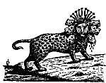  "I saw a BEAST rise up out of the SEA, having SEVEN HEADS and TEN HORNS, and upon his horns TEN CROWNS, and upon his heads the NAMES OF BLASPHEMY. And the BEAST which I saw was like unto a LEOPARD, and his feet were as the feet of a BEAR, and his mouth as the mouth of a LION; and the Dragon gave him his power, and his seat, and great authority. And I saw one of his HEADS as it were wounded to death; and his deadly wound was healed; and all the world wondered after the BEAST. . . . And there was given unto him a mouth speaking great things and blasphemies; and power was given unto him to continue FORTY AND TWO, MONTHS. And he opened his mouth in blasphemy against God, to blaspheme His Name, and His Tabernacle, and them that dwell in Heaven. And it was given unto him to make war with the saints, and to overcome them; and power was given him over all kindred.,, and tongues, and nations." | SCARLET COLORED BEAST  Rev. 17:3, 7-17  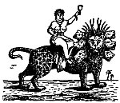  "I saw a Woman sit upon a scarlet colored BEAST, full of names of blasphemy, having SEVEN HEADS and TEN HORNS. . I will tell thee the mystery of the Woman, and of the BEAST that carried her, which hath the SEVEN HEADS and TEN HORNS. The BEAST that thou sawest WAS, and IS NOT; and shall ascend out of the BOTTOMLESS PIT, and go into perdition. The SEVEN HEADS are SEVEN MOUNTAINS, on which the Woman sitteth. And they (the Seven Heads, R. V.) are SEVEN KINGS; FIVE are fallen, and ONE is, and the OTHER is not yet come; and when he cometh, he must continue a short space. And the BEAST that WAS, and IS NOT, even he is the EIGHTH, and is of the SEVEN, and goeth into perdition. And the TEN HORNS which thou sawest are TEN KINGS, which have received no kingdom as yet; but receive power as kings one hour with the BEAST. These have one mind, and shall give their power and strength unto the BEAST. . . . And the TEN HORNS which thou sawest upon the BEAST, these shall hate the WHORE, and shall make her desolate and naked, and shall eat her flesh, and burn her with fire. For God hath put in their hearts to fulfil His will and to agree, and give their kingdom unto the BEAST, until the words of God shall be fulfilled."
Antichrist. As the revived Roman Empire it is seen coming up out of the sea of the nations, as the Antichrist it comes up out of the ABYSS. For instance it cannot be said of the Roman Empire of John's day, that it WAS, and IS NOT, for it was at the height of its power in John's day. Neither can it be said of it that it shall ascend out of the pit and go into PERDITION, that could only be said of a person. Again we must distinguish between the body of the "Beast" and its heads and horns. The body being that of a LEOPARD, with the feet of a BEAR, and the mouth of a LION is to show that the revived Roman Empire in its last stage will include the characteristics of the first "Three Wild Beasts" of Daniel, that is, of the LION (Babylon), the BEAR (Medo-Persia), and the LEOPARD (Greece), and as the largest part of the "Beast," the body, is represented by the LEOPARD, the prevailing characteristic of the revived Roman Empire will be GRECIAN.
The "Beast" that comes up out of the sea (Chap. 13), has SEVEN HEADS and TEN HORNS, and the "Horns" are CROWNED. This represents the "Beast," or Empire, at the height of its power, when it will have all its "Heads," and when the TEN KINGS, the heads of the TEN KINGDOMS into which the Empire shall be divided, will have been crowned. The "Beast" that comes up out of the ABYSS also has SEVEN HEADS and TEN HORNS, but they are not crowned, for the TEN KINGS represented by the TEN HORNS, have not as yet received their kingdom. (Rev. 17:12.) This implies that the "Beast" of Rev. 17, represents the Antichrist at the beginning of the "Week." As confirmation of this view the "WOMAN" is seen at this stage riding the "Beast." For while the "Scarlet Clothed Woman" is not seen until chapter 17, it is clear that she rides the "Beast" from the beginning of the "Week," for she represents the "PAPAL CHURCH" that comes into power after the true Church has been caught out. During the wars preceding the rise of Antichrist the nations that will then be found in the geographical limits of the Old Roman Empire will form an "Alliance" for mutual protection. Those nations will be ten in number, represented by the "TEN HORNS" of the Beast. No doubt the "Papal Church" will play a prominent part in those proceedings. She will be rewarded by restoration to political power, and this union of Church and State, in which the Church will have control, is shown by the WOMAN riding the Beast, thus dominating it. But when the "Ten Kings" shall receive their Kingdoms and be CROWNED, they "shall hate the WHORE, and shall make her desolate and naked, and shall eat her flesh, and burn her with fire." (Vs. 16.)
While we are told in Rev. 17:9 that the "SEVEN HEADS" of the "Beast" represent "SEVEN MOUNTAINS" (this is to identify it with the Roman Empire), we are told in the next verse (R. V.) that they (the "Seven Heads") also represent "SEVEN KINGS" of whom "Five are fallen, and one is, and the other is not yet come; and when he cometh he must continue a short space." That is, in John's day "Five" of these Kings had fallen, one was the then ruling Emperor, and the "Seventh" was yet to come. Who are meant by the first "Five Kings" that had fallen we do not know. The King that was on the throne in John's day was Domitian, who had banished John to the Isle of Patmos. The last or "SEVENTH KING" who is yet to come is undoubtedly the ANTICHRIST. We are told in Rev. 13:3, that one of the "SEVEN HEADS," or "KINGS," received a deadly wound. Which one is not stated. The inference is that it is the last, for the Beast has all of his "HEADS" before one of them is wounded. In Rev. 17:11 he is called the Beast that WAS, and IS NOT, even he is the "EIGHTH," and is of the "SEVENTH," and goeth into PERDITION. The only clear explanation of this passage is that the "SEVENTH HEAD"--THE ANTICHRIST, is the one who receives the "deadly wound," probably at the hand of an assassin, and as his body is lying in state prepared for burial, he rises from the dead (Vs. 14), and thus becomes the "EIGHTH," though he is of the "SEVENTH."
By this resurrection of the Antichrist, Satan imitates the Resurrection of Christ and makes the world "wonder after the Beast" (Rev. 13:3), and this adds to his prestige and power. If this happens at the "Middle of the Week," at the time the Dragon is cast out of Heaven, it will account for the great change that takes place in the Antichrist, for before receiving his "deadly wound" he will be sweet and lovable, but after his resurrection or recovery he will become Devilish, the result of the Dragon incarnating himself in him. It is at this time that he breaks the Covenant with the Jews and desecrates the Temple by setting up the "Abomination of Desolation" which is an "Idol Image" of himself--the "DESOLATOR." As the "LITTLE HORN" of Daniel's "Fourth Wild Beast" he will destroy three of the "Ten Kings" and firmly establish himself in the place of power, and as he, as the "LITTLE HORN," does not appear until after the "TEN HORNS," or "Ten Federated Kingdoms," come into existence, it is clear that the Antichrist does not form the Federation, but is the outgrowth of it.

THE ANTICHRIST
Fourth Wild Beast  Dan. 7:7, 8, 19.20, 23-25. | Daniel's Foreview  The Little Horn Of The He-Goat  Dan. 8:8-12, 23-25. | The Wilful King  Dan. 11:36-39. | Paul's Foreview  2 Thess. 2:3.12 | John's Foreview  Beast Out Of The Sea  Rev. 13:1-7
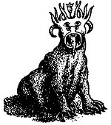 |  | 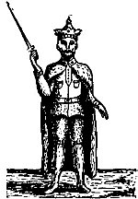 | 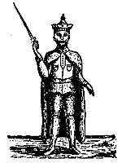 | 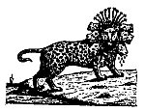
"After this I saw in the night visions, and behold a FOURTH BEAST, dreadful and terrible, and strong exceedingly; and it had greet iron teeth; it devoured and brake in pieces, and stamped the residue (the 3 preceding Beasts) with the feet of it; and it was diverse from all the Beasts that were before it; and it had TEN HORNS. I considered the HORNS, and, behold, there came up among them another LITTLE HORN, before whom there THREE of the FIRST HORNS plucked up by the roots; and, behold, in THIS HORN were eyes like the eyes of a MAN, and a mouth speaking great things."  "Then I would know the truth of the FOURTH BEAST, which was diverse from all the others, exceeding dreadful, whose teeth were of iron, and his nails of brass; which devoured, brake in pieces, and stamped the residue with his feet; and of the TEN HORNS that were in his head, and of the OTHER which came up, and before whom three fell; even of THAT HORN that had eyes, and a mouth spake very greet things, whose look was more stout then his fellows."  "Thus he said, the FOURTH BEAST shall be the FOURTH KINGDOM upon earth, which shall be diverse from all kingdoms, and shall devour the whole earth, and shall tread it down and break it in pieces. And the TEN HORNS out of this Kingdom are TEN KINGS that shall arise; and another (King) shall arise after them; and he shall be diverse from the first, and he shall subdue THREE KINGS. And he shall speak great words against the Most High, and shell wear out the saints of the Most High, and think to change times and laws; and they shall be given into his hand until a TIME and TIMES and the DIVIDING OF TIME." | "Therefore the He-Goat waxed very great; and when he was strong, the GREAT HORN was broken; and for it came up FOUR NOTABLE ONES toward the four winds of heaven. And out of one of them came forth a LITTLE HORN, which waxed exceeding great, toward the South and toward the East, and toward the Pleasant Land (Palestine). And it waxed great, even to the Host of Heaven; and it cast down some of the Host and of the Stars to the ground, and stamped upon them. Yea, he magnified himself even to the Prince of the Host and by him the daily sacrifice was taken away, and the place of his Sanctuary was cast down. And an host was given him against the daily sacrifice by reason of transgression, and it (he, the LITTLE HORN) cast down the truth to the ground and it (the LITTLE HORN) practised and prospered.  And in the LATTER TIME of their kingdom, when the TRANSGRESSORS ARE COME TO THE FULL, a King of FIERCE COUNTENANCE, and understanding dark sentences, shall stand up. And his power shall be mighty, but not by his own power; and he shall destroy wonderfully, and shall prosper, and practice, and shall destroy the mighty and the Holy People. And through his policy also he shall cause craft (all kinds of business) to prosper in his hand; and he shall magnify himself in his heart, and by peace shall destroy many: he shall also stand up against the PRINCE OF PRINCES (Christ) but he shall be broken without hand." | "And the KING shall do according to his Will; and he shall exalt himself and magnify himself above every god, and shall speak marvelous thing against the God of gods, and shall prosper till the indignation be accomplished; for that, that is determined, shall be done. Neither shall he regard the God of his fathers, or the desire of woman, nor regard any god; for he shall magnify himself above all. But in his estate shall he honor the God of forces; and a god whom his fathers knew not shall he honor with gold, and silver, and with precious stones and pleasant things. Thus shall he do in the most strong holds with a strange god, whom he shall acknowledge and increase with glory; and he shall call them to rule over many, and shall divide the land for gain" | 'Let no man deceive you by any means; no man for 'THAT DAY' (the Day of the Lord") shall not come except there come a falling away first, rod that  'MAN OF SIN'  be revealed. The  'SON OF PERDITION,'  who opposeth and exalteth himself above all, that is called God, or that is worshipped; so that he AS GOD sitteth in the Temple of God (the rebuilt Temple of Jerusalem), showing himself that he IS GOD. . . . For the  'MYSTERY OF INIQUITY'  doth already work (in Paul's day); only He (the Holy Spirit) who now letteth (restraineth, R. V.) will let (restrain), until He be taken out of the way. And then shall  'THAT WICKED'  be revealed, whom the Lord shall consume with the spirit (breath) of His Mouth and shall destroy with the brightness (manifestation, R. V.) of His Coming. Even him, whose coming is after the working of Satan with all power and signs and lying wonders, and with all deceivableness of unrighteousness in them that perish: because they received not the love of the Truth (Christ) that they might be saved. And for this cause God shall send them strong delusion that they should believe a lie (THE LIE. American Standard 1911 Bible), that they all might be damned who believed not the truth, but had pleasure in unrighteousness." | "I saw a BEAST rise up out of the SEA, having SEVEN HEADS and TEN HORNS, and upon his horns TEN CROWNS, and upon his heads the NAMES OF BLASPHEMY. And the BEAST which I sew war like unto a LEOPARD, and his feet were as the feet of a BEAR, and his mouth as the mouth of a LION; and the Dragon gave him his power, and his seat, and great authority. And I saw one of his HEADS as it were wounded to death; and his deadly wound was healed: and all the world wondered after the BEAST. . . . And there was given to him a mouth speaking great things and blasphemies; and power was given unto him to continue FORTY AND TWO MONTHS. And he opened his mouth in blasphemy against God, to blaspheme His Nome, and His Tabernacle, and them that dwell in Heaven. And it was given unto him make war with the saints, and to overcome them; and power was given him over all kindreds, and tongues, and nations".
He will be a "composite" man. One who embraces in his character the abilities and powers of Nebuchadnezzar, Xerxes, Alexander the Great and Caesar Augustus. He will have the marvelous gift of attracting unregenerate men, and the irresistible fascination of his personality, his versatile attainments, superhuman wisdom, great administrative and executive ability, along with his powers as a consummate flatterer, a brilliant diplomatist, a superb strategist, will make him the most conspicuous and prominent of men. All these gifts will be conferred on him by Satan, whose tool he will be, and who will thus make him the--
SUPERMAN.
He will pose as a great humanitarian, the friend of men, and the especial friend of the Jewish race, whom he will persuade that he has come to usher in the "Golden Age" as pictured by the prophets, and who will receive him as their Messiah.
He will intoxicate men with a strong delusion and his never varying success. And when he shall be slain and rise again he will have lost none of these powers, but will be in addition the embodiment of all kinds of wickedness and blasphemy.
"He shall speak great words against the Most High, and shall wear out the saints of the Most High, and think to change times and laws." Dan. 7:25.
"He shall also stand up against the 'Prince of Princes'" (Jesus). Dan. 8:25.
"He shall do according to his will; and he shall exalt himself and magnify himself above every god, and shall speak marvellous things against the God of Gods." Dan. 11:36.
"Who opposeth and exalteth himself above all that is called God, or that is worshipped; so that he AS GOD sitteth in the Temple of God (at Jerusalem) showing himself that he IS GOD. . . . whose coming is after the Working of Satan with all Power and Signs and Lying Wonders." 2. Thess. 2:3-9.
There has never as yet appeared on this earth a person who answers the description given in the above Scriptures. Such a character is almost inconceivable. No writer would have invented such a character.

THE EARTH.

The "False Prophet" Or "Anti-Spirit."
Rev. 13:11-18.
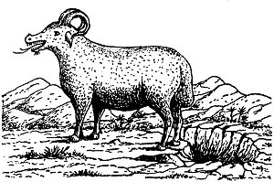
"And I beheld another 'BEAST' coming up out of the EARTH; and he had two horns like a lamb, and he spake as a DRAGON. And he exerciseth all the power of the 'First Beast' before him, and causeth the earth and them which dwell therein to worship the 'First Beast,' whose deadly wound was healed. And he doeth great wonders, so that he maketh fire come down from heaven on the earth in the sight of men, and deceiveth them that dwell on the earth by the means of those miracles which he had power to do in the sight of the 'Beast'; saying to them that dwell on the earth, that they should make an 'IMAGE TO THE BEAST,' which had the wound by a sword, and did live. And he had power to give LIFE UNTO THE 'IMAGE OF THE 'BEAST,' that the 'IMAGE OF THE BEAST' SHOULD BOTH SPEAK, AND CAUSE THAT AS MANY AS WOULD NOT WORSHIP THE 'IMAGE OF THE BEAST' SHOULD BE KILLED. And he causeth all, both small and great, rich and poor, free and bond, to receive a 'MARK' in their right hand, or in their foreheads; and that no man might BUY or SELL, save he that had the 'MARK,' or the 'NAME OF THE BEAST,' or the 'NUMBER OF HIS NAME.' Here is wisdom. Let him that hath understanding count the 'NUMBER OF THE BEAST': for it is the 'NUMBER OF MAN': and his number is SIX HUNDRED THREESCORE AND SIX."
After the Apostle John had seen and described the "Beast" that came up out of the SEA, he saw another "Beast" come up out of the EARTH. This "Second Beast," while John does not say it was a lamb, had "Two Horns" "like a lamb," that is, it was LAMB-LIKE. Because of this resemblance many claim that the "Second Beast" is the Antichrist, for Antichrist is supposed to imitate Christ. While the LAMB (Christ) is mentioned in the Book of Revelation 22 times, the description given of Him in chapter 5:6, is that of a lamb having "SEVEN HORNS" and not "TWO." This differentiates Him from the "lamb-like Beast" that comes up out of the earth, who, though he is "lamb-like in appearance SPEAKS AS A DRAGON."
The "Second Beast" has a name. He is called the "FALSE PROPHET" three times. First in chapter 16:13, then in chapter 19:20, and again in chapter 20:10. Twice he is associated with the "First Beast" (Antichrist) and once with the "Dragon" (Satan) and the "First Beast," and as they are PERSONS so must he be. The fact that he is called the "False Prophet" is proof that he is not the "Antichrist." Jesus had a foreview of him when He said--"There shall arise 'FALSE CHRISTS' and 'FALSE PROPHETS,' and shall show GREAT SIGNS AND WONDERS: insomuch that, if it were possible they shall deceive the very elect." Matt. 24:24. Here Jesus differentiates between "FALSE CHRISTS" and "FALSE PROPHETS," therefore the "ANTICHRIST" and the "FALSE PROPHET" cannot be the same.
That the "Second Beast" comes up out of the EARTH may signify that he will be a resurrected person. If, as was hinted at, "Antichrist" was Judas resurrected, why should not the "False Prophet" also be a resurrected person? There will be two persons, as we have seen, who shall come back from Heaven as the "Two Witnesses," Moses and Elijah, why not two persons come up from "The Underworld," brought up by Satan to counteract the work of the "Two Witnesses"? The fact that the "First Beast" (Antichrist), and the "Second Beast" (False Prophet) are cast ALIVE into the "Lake of Fire" (Rev. 19:20) is further proof that they are more than ordinary mortals, and that the "First Beast" is more than the last ruling Emperor of the revived Roman Empire. He is the Antichrist, Satan's SUPERMAN.
In the "Dragon," the "Beast," and the "False Prophet," we have the "SATANIC TRINITY," Satan's imitation of the "Divine Trinity." In the unseen and invisible "Dragon" we have the FATHER (the ANTI-GOD). In the "Beast" we have the "SON OF PERDITION" (the ANTI-CHRIST), begotten of the Dragon, who appears on the earth, dies, and is resurrected, and to whom is given a throne by his Father the Dragon. In the "False Prophet" we have the "ANTI-SPIRIT," who proceeds from the "Dragon Father" and "Dragon Son," and whose speech is like the Dragon's. The "Dragon" then will be the "ANTI-GOD," the "Beast" the "ANTI-CHRIST," and the "False Prophet" the "ANTI-SPIRIT," and the fact that all three are cast ALIVE into the "Lake of Fire" (Rev. 20:10) is proof that they together form a "Triumvirate" which we may well call--"THE SATANIC TRINITY."
Again the "Antichrist" is to be a KING and rule over a KINGDOM. He will accept the "Kingdoms of this world" that Satan offered Christ, and that Christ refused. Matt. 4:8-10. He will also EXALT himself, and claim to be God. 2. Thess. 2:4. But the "False Prophet" is not a King, He does not exalt himself, he exalts the "First Beast" (Antichrist). His relation to the "First Beast" is the same as the Holy Spirit's relation to Christ. He causeth the earth and them which dwell therein to worship the "First Beast." He also has power to give life, and in this he imitates the Holy Spirit. And as the followers of Christ are sealed by the Holy Spirit until the "Day of Redemption" (Eph. 4:30); so, the followers of Antichrist shall be sealed by the False Prophet until the "Day of Perdition." Rev. 13:16-17.
The False Prophet will be a "Miracle Worker." While Jesus was a "miracle worker," He did all His mighty works in the "power" of the Holy Spirit. Acts 10:38. Among the miracles that the False Prophet will perform he will bring down FIRE FROM HEAVEN. As we have seen under the work of the "Two Witnesses," chapter 11:1-14, there will probably be a "FIRE-TEST" between Elijah and the False Prophet, and the test as to who is God of Mt. Carmel will be repeated. That Satan, who will then energize the False Prophet, can do this is clear from Job 1:16, where Satan, having secured per-mission from God to touch all that Job had, brought down "fire from heaven" and burned up Job's sheep and servants.
The False Prophet then commands the people to make an
"IMAGE OF THE BEAST."
This is further proof that the "First Beast" is the Antichrist. It is a strange weakness of mankind that they must have some VISIBLE God to worship, and when the Children of Israel, who had been delivered from Egypt under Moses' leadership, thought he had forsaken them because he did not come down from the Mount, they called Aaron to make them gods which should go before them, and Aaron made for them the "GOLDEN CALF." Ex. 32:1-6. So the False Prophet will have the people make for the purpose of worship an "IMAGE OF THE BEAST." But the wonderful thing about the "IMAGE" is that the False Prophet will have power to give LIFE to it, and cause it to SPEAK, and to demand that all who will not worship it shall be put to death. In other words the "IMAGE" will be a living, speaking, AUTOMATON.

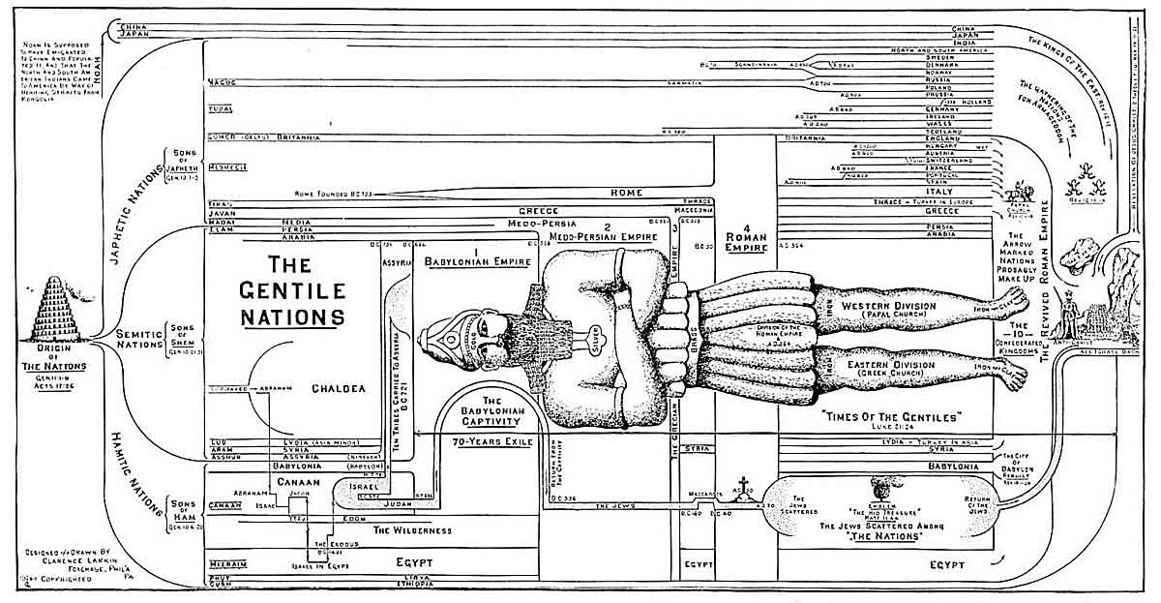
The Gentile Nations

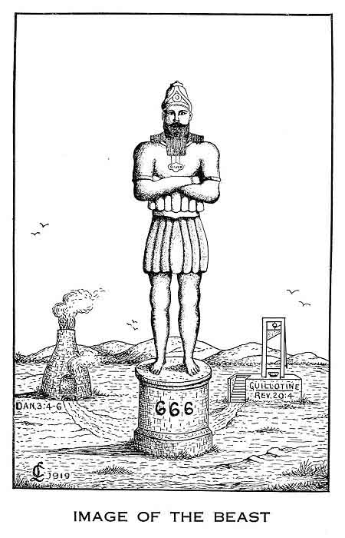
This "Image" reminds us of the "GOLDEN IMAGE" that Nebuchadnezzar commanded to be made and set up in the "Plain of Dura," in the Province of Babylon (Dan. 3:1-30), before which, at the sounding of musical instruments, the people were commanded to bow down and worship under penalty, for those who disobeyed, of being cast into a "BURNING FIERY FURNACE." Doubtless there will be many in the "Day of Antichrist" who will refuse to bow down and worship the "Image of the Beast," and who will not escape as did the "Three Hebrew Children," though God may inter-pose in a miraculous way to deliver some. And as if this was not enough the False Prophet shall cause--"ALL, both small and great, rich and poor, free and bond, to receive a 'MARK' in their RIGHT HAND, or in their FOREHEAD; and that no man might BUY or SELL, save he that has the 'MARK' or the 'NAME OF THE BEAST,' or the 'NUMBER OF HIS NAME'." This "MARK" will be known as the
"BRAND OF HELL."
This is what the world is fast coming to. The time is not far distant when the various "Trusts" and "Combinations of Capital"will be merged into a "FEDERATION OF TRUSTS," at the head of which shall be a "NAPOLEON OF CAPITAL." Ultimately this "Federation of Trusts" will extend to the whole world, at the head of which shall be THE ANTICHRIST, and the producer and consumer will be powerless in the tentacles of this OCTOPUS, and no man shall be able to BUY or SELL who has not the "MARK OF THE BEAST" either upon his "right hand" or on his "forehead." This "Mark" will be BRANDED or burnt on. It will probably be the "NUMBER OF THE BEAST" or "666." The number "666" is the "NUMBER OF MAN," and stops short of the perfect number SEVEN. Man was created on the SIXTH day. Goliath, the opposer of God's people, a type of Satan, was 6 cubits in height, he had 6 pieces of armor, and his spearhead weighed 600 shekels. 1. Sam. 17:4-7. Nebuchadnezzar's Image, a type of the "Image of the Beast," was 60 cubits in height, 6 cubits wide, and 6 instruments of music summoned the worshippers. Dan. 3:1-7.
In that day men will doubtless prefer to have the "MARK" on the back of their right hand so it can be readily seen in the act of signing checks, drafts, and receipts. There will doubtless be public officials in all public places of business to see that no one buys or sells who has not the "MARK." This will apply to women as well as men. No one can shop, or even buy from the huckster at the door, without the "MARK," under penalty of DEATH. Those will be awful times for those who will not WORSHIP THE BEAST. If they can neither buy or sell without the "MARK," they must beg, or starve or be killed. The instrument of death will be the guillotine (Rev. 20:4), and the daily papers will contain a list of the names of those who were beheaded the day before so as to frighten the people into obedience to the law. The doom of the "Satanic Trinity" will be, that at the close of that awful time of Tribulation the Lord Jesus Christ will return, and the "Dragon," the "Anti-God," will be cast into the "BOTTOMLESS PIT" for a 1000 years (Rev. 20:1-3), and the "Beast," the "Anti-Christ," and the "False Prophet," the "Anti-Spirit," will be cast ALIVE into the "LAKE OF FIRE." Rev. 19:20.

THE INTERVAL BETWEEN THE "SEVEN PERSONAGES" AND THE "SEVEN VIALS."
1. THE LAMB ON MOUNT ZION.
Rev. 14:1-5.
"And I looked, and, lo, a LAMB stood on MOUNT ZION, and with Him a Hundred Forty and Four Thousand, having His Father's name written in their foreheads. And I heard a voice from Heaven, as the voice of many waters, and as the voice of a great thunder: and I heard the voice of HARPERS harping with their harps: and they sung as it were a NEW SONG before the Throne, and before the Four Beasts, and the Elders: and no man could learn that song but The Hundred and Forty and Four Thousand, which were redeemed from the earth. These are they which were not defiled with women: for they are virgins. These are they which follow the Lamb whithersoever He goeth. These p. 131 were redeemed from among men, being the first fruits unto God and to the Lamb. And in their mouth was found no guile: for they are without fault before the Throne of God."
The Lamb here is Christ, and the Mount Zion is not Mount Zion of the earthly Jerusalem but of the Heavenly of which Paul speaks in Heb. 12:22-23. "But ye are come unto Mount Zion, and unto the city of the living God, 'THE HEAVENLY JERUSALEM,' and to an innumerable company of angels, to the General Assembly and Church of the 'First Born' (New Born), which are written in Heaven, and to God the Judge of all, and to the spirits of just (justified) men made perfect."
The 144,000 standing with the Lamb on Mount Zion, are the 144,000 "SEALED ONES," 12,000 from each Tribe of Israel, of chapter 7:3-8. There we are told they were sealed, here we are told why. In chapter seven we are told they were sealed in their foreheads, here we are told that that sealing was the writing on their foreheads of the name of the Lamb (R. V.) and of the Lamb's Father. As John looked at the Lamb and the 144,000 "Sealed Ones" who stood with Him, he heard a voice from Heaven, as the "voice of many waters," and as the voice of a "great thunder," which identifies the Speaker with the one who spoke from the midst of the "Lamp-Stands" of chapter 1:10, 15, or the Lamb Himself.
What the "voice" said is not told us, but it was followed with the voice or singing of "Harpers" accompanied by their harps. These "Harpers" sung a "NEW SONG" before the Throne, and the "Four Living Creatures," and the "Elders." As the "Elders" represent the Church, these "Harpers" are not the Church, for they sing before the "Elders." Who these "Harpers" are we are told in chapter 15:2-4. They are those who stand on the "Sea of Glass" before the Throne. Rev. 4:6. The "New Song" they sing is a "double song," the "SONG OF MOSES" and the "SONG OF THE LAMB," and we are told that no man could learn the Song but the 144,000 who were redeemed from the earth. This is further evidence that the 144,000 "Sealed Ones" are in Heaven, either having been translated or died a Martyr's death, and from Rev. 14:4 we learn that they are the "FIRST-FRUITS" of the restored nation of Israel, not the "First-Fruits" of the Church, for that is represented by the "Elders," and was gathered out long before.
These 144,000 "Sealed Ones" are called "VIRGINS"; and the fact that they are spoken of as not having been "defiled with women," shows that they are either all men of the character of the Apostle Paul, who did not marry, or, as is most likely, and as the word translated "virgins" means persons of either sex, they are "virgins" in the sense that they kept themselves clean of the crowning sin of that day--FORNICATION, for the crowning sin of the Tribulation Period will be fornication (Rev. 9:21; 14:8), or looseness and laxity of the marriage tie, of which "free-love," and the doctrine of "affinities," and multiplied divorce in these days are but the opening wedge to the looseness of morals of those Anti-Christian times. The 144,000 "Sealed Ones" will be especially delivered from this sin, and so they, and they only, as a special class, can sing this "New Song" of redemption, not so much by the Blood, as from the sin of fornication. The teaching of "seducing spirits" mentioned in 1. Tim. 4:1-3, as belonging to those Anti-Christian times, of "forbidding to marry and commanding to abstain from meats," has a deeper significance than that of the practice of the Church of Rome that requires the celibacy of the priesthood and clergy, and fasting of the laity. Such teaching comes from the "Pit," and belongs to Antichrist's religion, and its purpose is to weaken the body by fasting and make it more susceptible to the influence of evil angels and demons, and to cause it to gratify the desires of the flesh in other ways than by lawful means. These "Sealed Ones" are a chosen class who follow the Lamb whithersoever He goeth, and they are without fault before the Throne of God.

2. THE THREE ANGEL MESSENGERS.

FIRST ANGEL.

THE EVERLASTING GOSPEL.
Rev. 14:6-7.
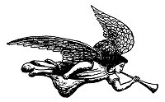
"And I saw another angel fly, in the midst of heaven, having the 'EVERLASTING GOSPEL' to preach unto them that dwell on the earth, and to every nation, and kindred, and tongue, and people; saying with a loud voice 'FEAR GOD, AND GIVE GLORY TO HIM; FOR THE HOUR OF HIS JUDGMENT IS COME: AND WORSHIP HIM THAT MADE HEAVEN, AND EARTH, AND THE SEA, AND THE FOUNTAINS OF WATERS."
In his vision of Apocalyptic Judgments John sees many angels at work. Here he sees one flying in "MID-HEAVEN." That is, in the heaven or atmosphere that surrounds our earth. The mission of this Angel is to preach the
"EVERLASTING GOSPEL"
unto every nation, kindred, tongue, and people on the earth. Here is the first and only place in the Bible where an angel is commissioned to preach the Gospel. An angel could not tell Cornelius how to be saved, he could only tell him to send for Peter for that purpose. Acts 10:3-6. In this "Gospel Age" only redeemed men can preach the Gospel, but at the "End Time," just before the return of the Lord, an angel will go forth to preach the "EVERLASTING GOSPEL," or as the revised Version puts it, the "ETERNAL GOSPEL." The word "Gospel" means "Good News." Four forms of the Gospel are mentioned in the New Testament, and we must distinguish carefully between them.

(1). THE GOSPEL OF "THE KINGDOM."
Matt. 24:14.
This is the "Good News" that God purposes to set up a Kingdom on this earth over which David's Son, JESUS, shall reign, as prophesied in Luke 1:32-33. Two preachings of this Gospel are mentioned, one past, beginning with the ministry of John the Baptist, and preached by Jesus and His Disciples, but it ended with the rejection of Jesus as King. This Gospel is to be preached again after the Church is taken out. It will be the fulfilment of Matt. 24:14, where it says: "This Gospel of 'THE KINGDOM' shall be preached in all the world for a WITNESS unto all nations: and then shall the end come." This has no reference to the Gospel that is now being preached. to the nations. It is the Gospel of SALVATION, but the "Gospel of the Kingdom" is not for "Salvation" but for a WITNESS, that is. it is the announcement that the time has come to SET UP THE KINGDOM. It will be preached first by Elijah the forerunner (Mal. 4:5-6): and by others who shall be commissioned to bear the news to all nations as a proclamation of the Coming of Christ as King to occupy the Throne of David, and for the purpose of regathering Israel to the Promised Land,

(2). THE GOSPEL OF THE "GRACE OF GOD."
Acts 20:24.
This is the "Good News" that Jesus Christ the rejected King died on the Cross for our SALVATION. This form of the Gospel is described in many ways. It is called the "GOSPEL OF GOD" (Rom. 1:1), because it has its source in the LOVE OF GOD. John 3:16. Its Character is "GRACE." Acts 20:24. Its subject is CHRIST (Rom. 1:16; 2. Cor. 10:14), and it is the POWER OF GOD UNTIL SALVATION. It is also a "GLORIOUS GOSPEL" because it speaks of Him who is in the GLORY, and has been GLORIFIED, and who is bringing many sons to GLORY. 1. Tim. 1:11, 2. Cor. 4:4, Heb. 2:10. And it is the "GOSPEL OF PEACE," because it makes peace between the sinner and God, and brings peace to the soul. Eph. 6:15.

(3). MY GOSPEL.
Rom. 2:16. (Acts 26:16-18.)
This is the same as the "Gospel of the Grace of God," or of Salvation, with the additional revelations that were made known to Paul as to the Church (Eph. 3:1-7), and as to Israel. Rom. 11:1-36.

(4) THE "EVERLASTING GOSPEL."
Rev. 14:6.
This is what the Angel preaches in this chapter. It is neither the "Gospel of the Kingdom," nor of "Grace." Its burden is not Salvation but JUDGMENT. "Fear God, and give glory to Him: for the HOUR OF HIS JUDGMENT IS COME." It is "Good News" to Israel, and all who are passing through the "fires of Judgment," because it declares that their troubles will soon end in the judgment and destruction of Antichrist. It calls on men to worship God as "Creator," and not as "Saviour," and so it is called in the Revised Version--"THE ETERNAL GOSPEL," the Gospel that has been proclaimed from Eden down by Patriarchs' and Prophets, and not an "Everlasting Gospel" in the sense that it saves men for all eternity.
There is "ANOTHER GOSPEL" (Gal. 1:6-12, 2. Cor. 11:4), which is not another, and which Paul repudiated. It is a perversion of the true Gospel and has many seductive forms, and in the main teaches that "faith" is not sufficient to Salvation, nor able to keep and perfect, and so emphasizes "Good Works." Col. 2:18-23, Heb. 6:1, 9:14. The Apostle pronounces a fearful "Anathema" upon its preachers and teachers. Gal. 1:8-9. Our message is: "Believe on the Lord Jesus Christ and thou shalt be saved." Acts 16:31. The Angel's message is: "Fear God for the HOUR of His Judgment is come." Men reject the human messenger and they will also reject the Angelic message, they will not believe even though the ONE (Jesus) rose from the dead.

SECOND ANGEL.

FALL OF BABYLON PROCLAIMED.
Chap. 14:8.
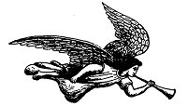
"And there followed another angel, saying BABYLON IS FALLEN, IS FALLEN, that great City, because she made all nations drink of the wine of the wrath of her fornication."
Here is proof that the City of Babylon is to be rebuilt. For further proof see chapter eighteen. As to the fall and destruction of the literal City of Babylon this proclamation is anticipative, but as a declaration that Babylon had fallen to fearful depths of wickedness and apostasy, and had become "the habitation of demons, and the hold of every foul spirit, and a cage of every unclean and hateful bird," as described in chapter 18:2, it was already true, for the City of Babylon
p. 135
will have been rebuilt at the time when this Angel utters his proclamation. The Angel's warning was that God's people might hear His voice saying: "Come out of her, MY PEOPLE, that ye be not partakers of her sins, and that ye receive not of her plagues." Rev. 18:4.

THIRD ANGEL.

THE DOOM OF ANTICHRIST'S FOLLOWERS.
Rev. 14:9-11.
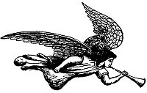
"And the third Angel followed them, saying with a loud voice, If any man worship the Beast and his Image, and receive his mark in his forehead, or in his hand, the same shall drink of the wine of the 'wrath of God,' which is poured out without mixture into the 'cup of His Indignation'; and he shall be tormented with fire and brimstone in the presence of the Holy Angels, and in the presence of the LAMB: and the smoke of their torment ascendeth up for ever and ever: and they have no rest day or night, who worship the Beast and his Image, and whosoever receiveth the 'Mark' of his name."
This is a most awful warning. Any man who worships the Beast, and receives his 'Mark' in forehead or hand, his doom is fixed FOREVER, and he shall be tormented with fire and brimstone in the presence of the Holy Angels and of the Lamb, and the smoke of his torment shall ascend for ever and ever, and they shall have no rest day or night. That means during the 3½ years of Antichrist's reign, after they have received the "Mark," for there is no day or night in eternity. If "Eternal Punishment" is taught nowhere else in the Bible it is taught here, and if here, why is it not true as to other classes of sinners? Just think of the horror of remorse in the "Lake of Fire," as these worshippers of the Beast shall recall the "Mark of the Beast" as it was imprinted on their forehead or right hand with their own consent because of their desire to enrich themselves in the markets of their day.

3. THE BLESSED DEAD.
Rev. 14:12-13.
"Here is the patience of the saints: here are they that keep the Commandments of God, and the Faith of Jesus. And I heard a voice from Heaven saying unto me, Write, blessed are the dead which die in the Lord FROM HENCEFORTH: Yea, saith the Spirit, that they may rest from their labors: and their works do follow them."
This is blessedly true of all saints but refers here to those who die after the False Prophet has issued the command that all who will not worship the "Image of the Beast shall be killed." Rev. 13:15. This is settled by the word HENCEFORTH. This warning is given for the benefit of those who in that day shall be tempted to compromise with evil in order to preserve their lives. Better to live and reign with Christ a 1000 years, than with Antichrist 3½ years. This special class of dead who "DIE IN THE LORD" will be blessed because they will be delivered from the trials and sufferings of the Great Tribulation, and will receive the "MARTYR'S CROWN" (Rev. 2:10), and they shall rest from their labors of stemming the tide of iniquity of those days, and their works follow with them (R. V.). During the "Great Tribulation" they that are loyal to God have no prospect before them but martyrdom, hence the need at this time of a special message of blessing to those who are faithful until death. What a contrast between the "Blessed Dead," and those who have the "Mark of the Beast." The former will rest from their labors, while the latter shall not rest day or night.

4. THE HARVEST AND VINTAGE.
Rev. 14:14-20.
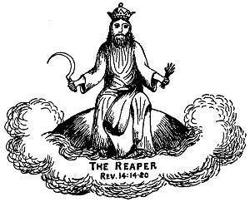
"And I looked, and behold a white cloud, and upon the cloud one sat like unto the SON OF MAN, having on His head a Golden Crown, and in His hand a sharp Sickle. And another angel came out of the Temple, crying with a loud voice to Him that sat on the cloud, Thrust in Thy SICKLE, and reap: for the time is come for Thee to reap: for the 'Harvest of the Earth' IS RIPE. And He that sat on the cloud thrust in His Sickle on the earth: and the earth was reaped. And another angel came out of the Temple which is in Heaven, he also having a sharp Sickle. And another angel came out from the Altar, which had power over fire; and cried with a loud cry to him that had the sharp Sickle, saying Thrust in thy sharp Sickle, p. 137 and gather the clusters of the 'VINE OF THE EARTH'; for her grapes are fully ripe. And the angel thrust in his Sickle into the earth, and gathered the 'VINE OF THE EARTH,' and cast it into the great WINEPRESS of the 'Wrath of God.' And the WINEPRESS was trodden without the city, and BLOOD came out of the WINEPRESS, even unto the horse bridles, by the space of a thousand and six hundred furlongs."
There can be no question as to who is the "Reaper" of the "HARVEST OF THE EARTH." It is the "SON OF MAN," Christ Himself. He was the "Sower" and He shall be the "Reaper." This is not the "Harvest of the Church." That was harvested in chapters four and five, and the "Reapers" were the angels. Matt. 13:39. This is the "Harvest" of the Gentile Nations'. In Joel 3:9-17 we have a description of this "Harvest and Vintage." The "Harvest and Vintage" are JUDICIAL. That is, they are for the purpose of Judgment. The account here is anticipative. It looks forward to chapter 16:13-16, which speaks of how the armies of the world are to be gathered together by "THREE UNCLEAN SPIRITS" to the Battle of the Great Day of God Almighty at Armageddon. This Battle takes place after the "Fall of Babylon," and is more fully described in chapter 19:17-19.
Here we are told that the Harvest is RIPE, and the "Son of Man" is commanded to thrust in His Sickle, which He does, and while the pouring out of the "Vials" is a part of the reaping, the Harvest is not finished until the end of the "Battle of Armageddon."
The difference between the "Harvest and the Vintage" is, that the "harvest" in the natural world precedes the "vintage," but often, as in this case, continues until they become one.
The "Vintage" is of the "VINE OF THE EARTH." Israel was a "VINE" brought out of Egypt (Psa. 80:8) and planted in Canaan, but when God looked for it to bring forth "good grapes" it brought forth "WILD GRAPES" (Isa. 5:1-7), and fruit unto itself. Hosea 10:1. When the Lord of the "Vineyard" sent His servants for the "Fruit of the Vineyard," the husbandmen beat one, killed another, and stoned another. At last He sent His Son, Him they took and cast out of the Vineyard and slew. Matt. 21:33-43. Then Jesus Himself became the "TRUE VINE," of which His disciples are the branches. John 15:5. The "VINE OF THE EARTH" is Antichrist and all who belong to his pernicious system.
The "WINEPRESS" is the winepress of the "FIERCENESS AND WRATH OF ALMIGHTY GOD." Rev. 19:15. The Prophet Isaiah (Isa. 63:1-6) describes Christ's share in it. It will cover the whole Land of Palestine, and extend as far south as Edom and Bozrah. So great shall be the slaughter that the blood shall be up to the horses' bridles in the valleys over the whole of Palestine for 1600 furlongs, or 200 miles. It will be the time of which the Prophet Isaiah speaks, when the land shall be DRUNK WITH BLOOD. Isa.. 34:7-8. We will consider it more in detail when we study the Battle of Armageddon in chapter nineteen.

The Seven Last Plagues or Vial Judgments.
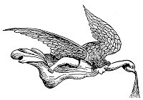
Rev. 15:1.
"And I saw another SIGN in Heaven, great and marvellous, SEVEN ANGELS having the 'SEVEN LAST PLAGUES'; for in them is filled up the WRATH OF GOD."
This is another "SIGN" or "Wonder." It was great and marvellous, because it "FILLED UP THE WRATH OF GOD," that is, it completed the pouring out of the accumulated "WRATH OF GOD."

PRELUDE.

THE SEA OF GLASS.
Rev. 15:2-4.
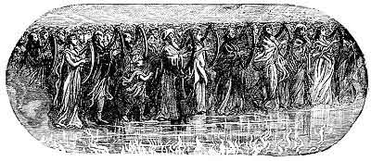
"And I saw as it were a 'SEA OF GLASS' MINGLED WITH FIRE: and them that had gotten the victory over the Beast, and over his Image, and over his Mark, and over the NUMBER OF HIS NAME, stand on the SEA OF GLASS, having the Harps of God. And they sing the SONG OF MOSES the servant of God, and the SONG OF THE LAMB, saying, Great and Marvellous are Thy Works, Lord God Almighty; just and true are Thy Ways, Thou King of Saints. Who shall not fear Thee, O Lord, and glorify Thy name? for thou only art holy! for all nations shall come and worship before Thee; for Thy judgments are made manifest."
This "SEA OF GLASS" is the same "Sea of Glass" that we saw before the Throne in chapter 4:6. Then it was unoccupied, now it is occupied. Then its surface was crystal clear and plain, now its surface is of a "fiery" aspect, symbolizing the "fiery trials" of its occupants. The occupants of this "Sea of Glass" come out of the Great Tribulation, for they have gotten the victory over the "Beast," and over his "Image," and over his Mark, and over the "Number of His Name," and they have harps, and they sing the "SONG OF MOSES" and the "SONG OF THE LAMB." They are the "Harpers" of chapter 14:2, whose song only the 144,000 "Sealed Ones" could sing. John only heard them then, now he sees them. That they could sing both the "Song of Moses" and the "Song of the Lamb" implies that they were all or in part Israelites. Some think that the "Song of Moses" that they sung was the song the Children of Israel sang on the shore of the Red Sea after their escape from Egypt, as given in Ex. 15:1-22, while others think it is Moses' "SWAN SONG" as found in Deu. 31:19, 22; 31:30; 32:43. They sang the "Song of the Lamb" because as Israelites they had been redeemed by the blood of the Lamb.

THE TABERNACLE OF TESTIMONY.
Rev. 15:5-8.
"And after that I looked, and behold, the Temple of the 'TABERNACLE OF TESTIMONY' in Heaven was opened: and the 'Seven Angels' came out of the Temple, having the 'SEVEN PLAGUES,' clothed in pure and white linen, and having their breasts girded with Golden Girdles. And one of the 'Four Beasts' gave unto the 'Seven Angels' 'SEVEN GOLDEN VIALS' full of the 'WRATH OF GOD,' who liveth for ever and ever. And the Temple was filled with smoke from the Glory of God, and from His Power: and no man was able to enter into the Temple, till the 'SEVEN PLAGUES' of the 'Seven Angels' were fulfilled."
Here again we see the Heavenly Temple. The "Seven Angels" that come out of it are clothed in priestly garments, and the "Golden Vials" that they carry were given them by one of the "Beasts" or Living Creatures, which one is not mentioned, and when he gave them to them the Heavenly Temple was filled with smoke. When the Tabernacle was finished by Moses, and the Temple by Solomon, there was a "cloud," the "Shekinah Glory," but no smoke. Ex. 40:34-36. 1. Kings 8:10-11. The "cloud" means GRACE, the "smoke" means JUDGMENT. Isa. 6:14. Ex. 19:18.

FIRST VIAL.

(Boils.)
Rev. 16:1-2.
"And I heard a great voice out of the Temple saying to the 'Seven Angels,' Go your ways, and pour out the 'VIALS OF THE WRATH OF GOD' upon the earth. And the first went, and poured out his VIAL upon the earth: and there fell a noisome and grievous sore upon the men which had the 'MARK OF THE BEAST,' and upon them which WORSHIPPED HIS IMAGE."
These "VIALS" and their contents are LITERAL. One cannot imagine that such momentous things as are here described refer to historical events that are already past, as when some interpret the "First Vial" as the French Revolution in A. D. 1792, and the "sores" its infidelity; and the "Second Vial" as the naval wars of that Revolution; the "Third Vial" as the battles of Napoleon in Italy, and the rest of the Vials as historical events that happened in the Nineteenth Century. If this be true then we have been passing in the past 125 years through the period of the Great Tribulation without knowing it, and have been preaching "Grace" and not that "THE HOUR OF HIS JUDGMENT IS COME." This is supposition and not EXPOSITION, and requires the reader of the Book of Revelation to be versed in all the historical events of the Christian Era. No, these "Vial Judgments" are yet future, and will be literally fulfilled as here described, and this gives us the "KEY" to the LITERALNESS of the whole Book of Revelation. That these "Vial Judgments" are not figurative is clear from the fact that 4 of the 7 have actually happened before. They are simply repetitions of the "PLAGUES OF EGYPT." See the "Chart on the " and the "Egyptian Plagues" compared. This Plague of a "NOISOME AND GRIEVOUS SORE" that shall fall upon men, is a repetition of the "Plague of Boils" that fell upon the Egyptians at the time of the Exodus. Ex. 9:8-12. The "First Vial Judgment" then will be a repetition of the "Sixth Egyptian Plague." That that Plague actually happened no believer in the Bible doubts, then why should we try to explain away the literalness of the Plagues that shall follow the pouring out of each of these Vials.
Boils are caused by bad blood, and reveal corruption in the system. These "grievous sores" which will come upon MEN ONLY, and not upon the beasts also as in the time of Moses, will not only reveal corruption in the body, but in the heart of those whose sins will cause corruption in their bodies. That these "sores" are reserved for those who have the "MARK OF THE BEAST," and who worship his IMAGE is further proof that these "Vial Judgments" are still future. Here is the fulfillment of Rev. 14:9-11.
The effect of the Plague of Boils upon the Egyptians was to harden their hearts, and a like effect will be produced upon the followers of Antichrist by the Plagues that shall follow the pouring out of the "Vials," for we read in verse 9, that men will blaspheme God, and refuse to repent. From this we see that suffering alone does not lead to repentance.
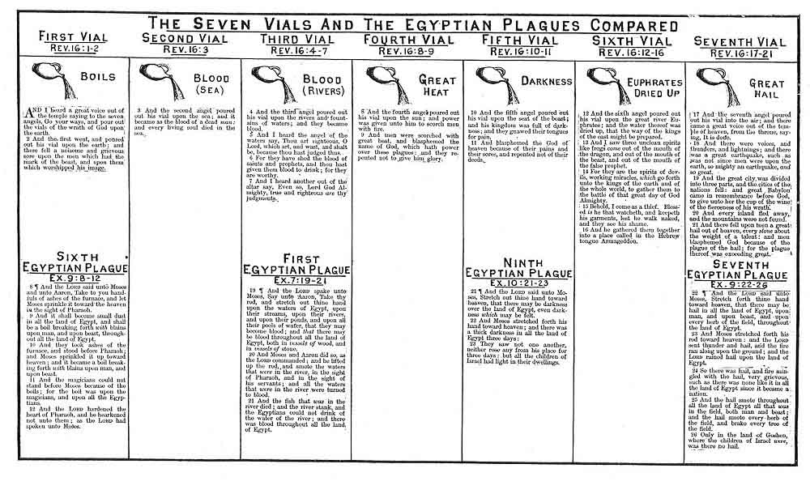

SECOND VIAL.

(Blood On the Sea.)
Rev. 16:3.
"And the 'Second Angel' poured out his Vial upon the sea: and it became as the blood of a dead man: and every living soul died in the sea."
We saw that at the sounding of the "Second Trumpet," that the third part of the sea became blood, and the third part of the creatures which were in the sea, and had life, died; and the third part of the ships were destroyed. Rev. 8:8-9. Here the whole of the sea is affected. This may mean only the Sea of Galilee, or the Mediterranean Sea, and not the oceans of the earth. It does not follow that this blood is that of men. It may be only of the living creatures that are in the sea. The Revised Version translates (in the margin) the word "soul" as the "soul of life," and we know that the word "soul" implies "self conscious life," and this is common to all animal life. The blood is certainly not the blood of sailors and marines caused by some great naval battle. The inference is that the creatures in the sea died, not because of the loss of their own blood, but because the waters of the sea became "AS the blood of a dead man"--that is, corrupt.

THIRD VIAL.

(Blood On the Rivers.)
Rev. 16:4-7.
"And the 'Third Angel' poured out his Vial upon the rivers and fountains of waters; and they BECAME BLOOD. And I heard the 'Angel of the Waters' say, Thou art righteous, O Lord, which art, and wast, and shalt be, because Thou hast judged thus. For they have shed the blood of saints and prophets, and Thou hast given them BLOOD TO DRINK; for they are worthy. And I heard another out of the Altar say, Even so, Lord God Almighty, true and righteous are Thy Judgments."
This is a repetition of the "First Egyptian Plague." Ex. 7:19-24. When the waters of Egypt were turned into blood all the fish died, but here nothing is said about the inhabitants of the rivers and ponds. Then John heard the "Angel of the Waters" say--"Thou art righteous, O Lord, which art, and wast, and shall be, because Thou hast judged thus. For they have shed the blood of saints and prophets, and Thou hast given them BLOOD TO DRINK; for they are worthy," or deserve it. As a confirmation of the saying of the "Angel of the Waters," John heard another voice come from the Altar, saying, "Even so, Lord God Almighty, true and righteous are Thy Judgments." Those will be awful times when there will be nothing but BLOOD to quench the thirst. The expression "Angel of the Waters," reveals the fact that even certain divisions of nature are controlled by angels.

FOURTH VIAL.

(Great Heat.)
Rev. 16:8-9.
"And the 'Fourth Angel' poured out his Vial UPON THE SUN; and power was given unto him (the Sun) to scorch men with fire. And men were scorched with GREAT HEAT, and blasphemed the name of God, which hath power over these Plagues; and they repented not to give Him glory."
Under the "Fourth Trumpet" the third part of the Sun was smitten, and the third part of the Moon and of the Stars; so as the third part of them was darkened, and the day shone not for a third part of it, and the night likewise. Rev. 8:12. But it was only the light that was diminished; nothing is said about the heat of the Sun. This "Fourth Vial" is therefore not a recurrence of the "Fourth Trumpet." Here the heat of the Sun is intensified, and so great is the heat that men are scorched by it. How this will be done it is useless to conjecture. It is the time spoken of by Malachi. "Behold, the day cometh that shall BURN AS AN OVEN; and all the proud, yea, and all that do wickedly, shall be stubble; and the day that cometh shall burn them up, saith the Lord of Hosts, that it shall leave them neither root nor branch"; and the time is located as just before the "SUN OF RIGHTEOUSNESS" shall arise with healing in His wings. Mal. 4:1-2. The effect of this Plague will be not to make men repent, but to cause them to blaspheme the name of God. Blessed will those people be who do not live to see that day.

FIFTH VIAL.

(Darkness.)
Rev. 16:10-11.
"And the 'Fifth Angel' poured out his Vial upon the SEAT (Throne) OF THE BEAST: and his Kingdom was full of darkness; and they GNAWED THEIR TONGUES FOR PAIN, and blasphemed the God of Heaven because of their 'PAINS' and their 'SORES,' and repented not of their deeds."
Here we have a repetition of the "Ninth Egyptian Plague," that of DARKNESS. Ex. 10:21-23. This is the "day" spoken of by Joel. "A day of darkness and of gloominess, a day of clouds and of thick darkness." Joel 2:1-2. Christ speaks of it in Mark 13:24, as the time when "the Sun shall be darkened, and the Moon shall not give her light."
Notice that this Plague immediately follows the Plague of "Scorching Heat," as if God in mercy would hide the Sun whose rays had been so hard to bear. The effect of the darkness was to make men gnaw their tongues for PAIN and for their SORES, showing that these Plagues overlapped each other, or followed in such rapid order that they were not over the sufferings of one before they were suffering from another, and that they were limited to a short period of a few months, and not distributed over a period of years as the Historical School of interpretation claims. The notable feature is, that their sufferings brought no repentance, but caused them to blaspheme the God of Heaven. Some talk of conversion in Hell, and of the ultimate restoration of the wicked, but it is not revealed here. If Hell's torments will cause men to repent, why do not the torments of those under these plagues lead to repentance? No, it only causes them to blaspheme the more, and while sin and impenitence last, Hell lasts. This Plague extends over the whole Kingdom of the Beast.

SIXTH VIAL.

(The Euphrates Dried Up.)
Rev. 16:12.
"And the 'Sixth Angel' poured out his Vial upon the GREAT RIVER EUPHRATES; and the water thereof was DRIED UP, that the way of the 'Kings of the East' might be prepared."
This means the literal river Euphrates. The other Plagues will be real, and why does not this mean the drying up of the real Euphrates River. The opening up of a dry passage through the Red Sea that the Children of Israel might escape from Egypt, and the parting of the waters of the River Jordan that they might pass over into the Land of Canaan, are facts of history, why then shall not the River Euphrates be dried up that the Kings of the East and their armies may cross over and assemble for the Battle of Armageddon? The prophecy in Isa. 11:15-16, where "the Lord shall utterly destroy the tongue of the Egyptian Sea (Red Sea), and . . . shake His hand over the River (Euphrates) and smite its seven streams, so men can go over 'DRY SHOD'," refers to this time. The Kings shall journey East from Africa, and West from Asia that they may meet in Palestine for the "Battle of Armageddon." The drying up of the Euphrates will serve a twofold purpose. It will permit the remnant of Israel from Assyria to return, and also allow the nations of the far East to be gathered for the "Judgment of Nations." Matt. 25:31-46.

THE INTERVAL BETWEEN THE "SIXTH" AND "SEVENTH" VIALS.

THREE UNCLEAN SPIRITS.
Rev. 16:13-16.
"And I saw THREE UNCLEAN SPIRITS like frogs come out of the mouth of the 'Dragon,' and out of the mouth of the 'Beast,' and out of the mouth of the 'False Prophet.' For they are the 'SPIRITS OF DEVILS' (Demons), working miracles, which go forth unto the 'Kings of the Earth' and of the whole world, to gather them to the Battle of that 'Great Day of God Almighty' (Armageddon). Behold I come as a thief. Blessed is he that watcheth, and keepeth his garments, lest he walk naked, and they see his shame. And he (they R. V.) gathered them together into a place called in the Hebrew tongue Armageddon." (Har-Mageddon R. V.)
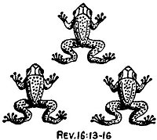
REV. 16:13-16
Here we are told how the "Kings of the Earth" and their armies are to be gathered for the "Battle of Armageddon." "THREE UNCLEAN SPIRITS" like frogs, John does not say they were frogs, will come one out of the mouth of the "Dragon," one out of the mouth of the "Beast," and one out of the mouth of the "False Prophet." That they are not real frogs is clear from their miracle working power. They are the "SPIRITS OF DEMONS," working miracles, which go forth unto the "Kings of the Earth," and of the whole world, to gather them to the "Battle of that Great Day of God Almighty." They are the "Seducing Spirits" who go forth preaching the "DOCTRINE OF DEVILS" in the "latter times" of whom Paul warns Timothy. 1. Tim. 4:1. They are sent out by the "SATANIC TRINITY," the "Dragon," the "Beast," and the "False Prophet," on a miracle working ministry.
They are "frog-like" in that they come forth out of the pestiferous quagmires of darkness, do their devilish work in the evening shadows of "Man's Day," and creep, and croak, and defile, and fill the ears of the nations with their noisy demonstrations, until they set the kings and armies of the nations in enthusiastic commotion and movement toward the Holy Land to crush out the effort to establish the Kingdom of Christ on earth. We have an illustration of their method and purpose in the story of the destruction of King Ahab. 1. Kings 22:20-38.
The power of a delusive and enthusiastic sentiment, however engendered, to lead to destruction great hosts of men is seen in the Crusades to recover the Holy Sepulchre at Jerusalem. If a religious fanaticism could, at 9 different times, cause hundreds of thousands of religious devotees to undergo unspeakable hardships for a religious purpose, what will not the miracle working wonders of the "FROG-LIKE DEMONS" of the last days of this Dispensation not be able to do in arousing whole nations, and creating vast armies to march in all directions from all countries, headed by their Kings, for the purpose of preventing the establishment of the Kingdom of the King of Kings in His own Land of Palestine?

SEVENTH VIAL.

(Great Hail.)
Rev. 16:17-21.
"And the 'Seventh Angel' poured out his Vial INTO THE AIR: and there came a great voice out of the Temple of Heaven, from the Throne, saying--IT IS DONE. And there were VOICES, and THUNDERS, and LIGHTNINGS; and there was a GREAT EARTHQUAKE, such as was not since men were upon the earth, so mighty an earthquake, and so great. And the Great City (Jerusalem) was divided into three parts, and the cities of the nations fell, and Great Babylon came in remembrance before God, to give unto her the cup of the wine of the fierceness of His wrath. And every island fled away, and the mountains were not found (they will be leveled). And there fell upon men a GREAT HAIL out of heaven, every stone about the weight of a talent: and men blasphemed God because of the Plague of the Hail; for the Plague thereof was exceeding great."
It is worthy of note that at the breaking of the "Seventh SEAL," and the sounding of the "Seventh TRUMPET," and the pouring out of the "Seventh VIAL," that the same things occur. That is, voices and thunderings are heard, great lightning is seen, and there is a GREAT EARTHQUAKE. And at the sounding of the "Seventh TRUMPET," and the pouring out of the "Seventh VIAL" there is a GREAT HAIL STORM. This only confirms what has been already stated that the "SEVENTH SEAL" includes the 'Trumpets" and "Vials," and that the "SEVENTH TRUMPET" includes the "Vials," and that what happens during the "Seventh SEAL," and the "Seventh TRUMPET," and the "Seventh VIAL," all refers to the same period, the "END OF THE WEEK." In other words, the opening of the "Seventh SEAL" reveals the events that are about to happen; the blast of the "Seventh TRUMPET" announces the events as forth-coming, and the outpouring of the "Seventh VIAL" executes them.
When the "Seventh SEAL" was broken there was "SILENCE" in Heaven, but when the "Seventh TRUMPET" sounded, and the "Seventh VIAL" was poured out there were "GREAT VOICES" in Heaven. The "Great Voice" at the pouring out of the "Seventh Vial" was from the Throne, and cried--"IT IS DONE." When Christ expired on the Cross He cried--"IT IS FINISHED," that is, the way and plan of Salvation was complete, and this voice from the Throne that cries "IT IS DONE" may be His voice, announcing that the pouring out of the "Seventh Vial" finishes the wrath of God.
The "Great Earthquake" that follows will be the greatest that this world has ever seen. It is foretold in Zech. 14:4-5. So great will it be, that it will level the mountains, and destroy islands, and so change the contour and shape of the Land of Palestine and the surrounding countries and seas, as to make new maps of that part of the world necessary; and it will raise the Dead Sea so that its waters shall flow again into the Red Sea. Ez. 47:1-12. It will divide the "Great City" (Jerusalem) into 3 parts, and the cities of the Nations (the "Ten Federated Nations"), and "GREAT BABYLON," whose destruction is described in chapter eighteen, will be destroyed in that "Great Earthquake." This reference to the "City of Babylon" is further incidental proof that the City of Babylon is to be rebuilt. Among the cities destroyed in that Earthquake will be Rome, Naples, London, Paris, and Constantinople.
At that time there will fall upon men a "GREAT HAIL." Each stone will weigh about a Talent, or 100 pounds. Here we have a repetition of the "SEVENTH EGYPTIAN PLAGUE." Ex. 9:13-35. Hail has been one of God's engines of destruction. He used it to discomfit the enemies of Israel at Beth-horon in the days of Joshua. Josh. 10:11. The "Law" required that the "Blasphemer" should be "STONED TO DEATH" (Lev. 24:16), and here these Blasphemers of the "End Time" shall be STONED FROM HEAVEN.
It must not be forgotten that the "Seventh Vial" covers the whole period from the time the "Seventh Angel" pours out its contents until Christ returns to the Mount of Olives. For the earthquake that splits the Mount of Olives, upheaves the land of Palestine, levels mountains, submerges islands, and destroys the cities of the Nations, along with the City of Babylon, is caused by the touch of Christ's feet on the Mount of Olives at the Revelation stage of His Second Coming (Zech. 14:4), and the "Great Hail" in all probability will not fall until the time comes in the crisis of the Battle of Armageddon for the destruction of the Allied armies of Antichrist. Hailstones will be the missiles used by the Armies of Heaven.
In Rev. 19:15, we are told that out of the mouth of Christ, at His return, will go a "SHARP SWORD," that with it He should smite the nations, and in 2 Thess. 2:8, we are told that Antichrist (that WICKED), shall be consumed by the "SPIRIT OF THE LORD'S MOUTH." Whether we take these statements as literal or not, it is clear that they stand for some supernatural means of destruction, and refer more to the followers of Antichrist, than to Antichrist himself, for he personally is not to be destroyed, but is to be cast ALIVE into the "Lake of Fire." Rev. 19:20.
As the pouring out of the "Seventh Vial" finishes the "Wrath of God," it is in harmony with the purposes of the Book of Revelation to foretell at this point what will then happen to the enemies of God. These we will now examine under the heading the "Seven Dooms."
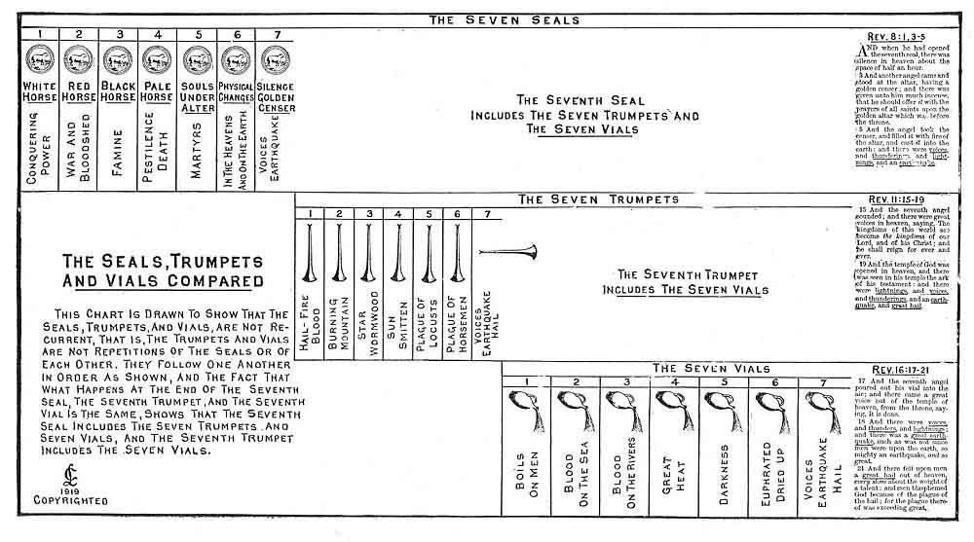

The Seven Dooms.

FIRST DOOM.

ECCLESIASTICAL BABYLON.

"MYSTERY

BABYLON THE GREAT."
Rev. 17:1-18.
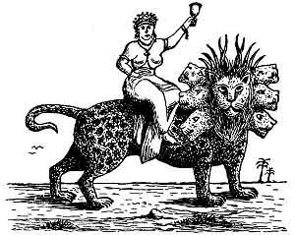
"And there came one of the 'Seven Angels' which had the 'Seven Vials,' and talked with me, saying unto me, Come hither: I will chew unto thee the Judgment of the 'GREAT WHORE' that sitteth upon many waters; with whom the kings of the earth have committed fornication, and the inhabitants of the earth have been made drunk with the wine of her fornication. So he carried me away in the spirit into the wilderness; and I saw a 'WOMAN' sit upon a 'SCARLET COLORED BEAST,' full of names of blasphemy, having 'SEVEN HEADS' and 'TEN HORNS.' And the 'WOMAN' was arrayed in purple and scarlet color, and decked with gold and precious stones and pearls, having a 'GOLDEN CUP' in her hand full of abominations and filthiness of her fornication: and upon her forehead was a name written
MYSTERY,
BABYLON THE GREAT,
THE MOTHER OF HARLOTS AND
ABOMINATIONS OF THE EARTH.
And I saw the 'WOMAN' drunken with the blood of the saints, and with the blood of the martyrs of Jesus; and when I saw her, I wondered with great admiration. And the Angel' said unto me, Wherefore didst thou marvel? I will tell thee the MYSTERY of the 'WOMAN,' and of the BEAST that carrieth her, which hath the SEVEN HEADS and TEN HORNS. The BEAST that thou sawest was, and is not; and shall ascend out of the BOTTOMLESS PIT, and go into PERDITION: and they that dwell on the earth shall wonder, whose names were not written in the 'Book of Life' from the foundation of the world, when they behold p. 150 the BEAST that was, and is not, and yet is. And here is the mind which hath wisdom. The SEVEN HEADS are seven mountains, on which the 'WOMAN' sitteth. And there (they, the mountains R. V.) are SEVEN KINGS: five are fallen, and one is, and the other is not yet come: and when he cometh, he must continue a short space. And the BEAST that was, and is not, even he is the EIGHTH, and is OF THE SEVENTH, and goeth into Perdition. And the TEN HORNS which thou sawest are TEN KINGS, which have received no kingdoms as yet; but receive power as kings one hour with the BEAST. These have one mind, and shall give their power and strength unto the BEAST. These shall make war with the LAMB, and the LAMB shall overcome them: for he is LORD OF LORDS, and KING OF KINGS: and they that are with Him are called, and chosen, and faithful. And he saith unto me, the waters which thou sawest, where the WHORE sitteth, are peoples, and multitudes, and nations, and tongues. And the TEN HORNS which thou sawest upon the BEAST, these shall hate the WHORE, and shall make her desolate and naked, and shall eat her flesh, and burn her with fire. For God hath put in their hearts to fulfil His will, and to agree, and give their kingdom unto the BEAST, until the words of God shall be fulfilled. And the WOMAN which thou sawest is that great city, which reigneth over the kings of the earth."
That the ancient city of Babylon restored is to play an important part in the startling events of the last days of this Dispensation, is very clear. This is seen from what is said of it in the seventeenth and eighteenth chapters of the Book of Revelation. At first sight the two chapters, which contain some things in common, are difficult to reconcile, but when we get the "Key" the reconciliation is easy. The seventeenth chapter speaks of a "Woman," and this "Woman" is called
"MYSTERY,
Babylon the Great,
The Mother of Harlots
And
Abominations of the Earth."
The eighteenth chapter speaks of a "City," a literal city, called "Babylon the Great." That the "Woman" and the "City" do not symbolize the same thing is clear, for what is said of the "Woman" does not apply to a city, and what is said of the "City" does not apply to a woman. The "Woman" is destroyed by the "Ten Kings," while the "Kings of the Earth" in the next chapter, "bewail and lament" the destruction of the "City," which is not destroyed by them, but by a mighty earthquake and fire. Again the "Woman" is destroyed Three and a Half Years BEFORE THE CITY; and the fact that the first verse of chapter eighteen says--"after these things," that is after the destruction of the "Woman," what happens to the "City" occurs, shows that the "Woman" and the "City" are not one and the same. The "Woman's" name is
"MYSTERY, Babylon the Great."
"Mystery!" Where have we heard that word before, and in what connection? Paul calls the Church a "Mystery" because it was not known to the Old Testament Patriarchs and Prophets. Eph. 3:1-21. That Christ was to have a "Bride" was first revealed to Paul (Eph. 5:23-32), and the "Mystery" that Antichrist is to have a "bride" was first revealed to John on the Isle of Patmos. The name of Antichrist's "bride" is "Babylon the Great." Some one may ask why give to a "bride" the name of a "City"? The answer is that it is not unusual in the Scriptures. When the same angel that showed John in this chapter "Mystery, Babylon the Great," came to him in chapter 21:9-10 and said--"Come hither, I will shew thee the Bride--'The Lamb's Wife'," he showed John, instead of a woman, that great City, the "Holy Jerusalem" descending out of Heaven from God. Here we see that a "city" is called a "bride" because its inhabitants, and not the city itself, are the bride. "Mystery, Babylon the Great," the "bride" of Antichrist, then, is not a literal city, but a "System," a religious and apostate "System." As the Church, the Bride of Christ, is composed of regenerated followers of Christ, so "Mystery, Babylon the Great," the bride of Antichrist, will be composed of the followers of all False Religions.
The river Euphrates, on which the city of Babylon was built, was one of the four branches into which the river that flowed through the Garden of Eden was divided, and Satan doubtless chose the site of Babylon as his headquarters from which to sally forth to tempt Adam and Eve. It was doubtless here that the Antediluvian Apostasy had its source that ended in the Flood. To this centre the "forces of Evil" gravitated after the Flood, and "Babel" was the result. This was the origin of nations, but the nations were not scattered abroad over the earth until Satan had implanted in them the "Virus" of a doctrine that has been the source of every false religion the world has ever known.
Babel, or Babylon, was built by Nimrod. Gen. 10:8-10. It was the seat of the first great Apostasy. Here the "Babylonian Cult" was invented. A system claiming to possess the highest wisdom and to reveal the divinest secrets. Before a member could be initiated he had to "confess" to the Priest. The Priest then had him in his power. This is the secret of the power of the Priests of the Roman Catholic Church today.
Once admitted into this order men were no longer Babylonians, Assyrians, or Egyptians, but members of a
Mystical Brotherhood,
over whom was placed a Pontiff or "High Priest," whose word was law. The city of Babylon continued to be the seat of Satan until the fall of the Babylonian and Medo-Persian Empires, when he shifted his Capital to Pergamos in Asia Minor, where it was in John's day. Rev. 2:12, 13.
When Attalus, the Pontiff and King of Pergamos, died in B. C. 133, he bequeathed the Headship of the "Babylonian Priesthood" to Rome. When the Etruscans came to Italy from Lydia (the region of Pergamos), they brought with them the Babylonian religion and rites. They set up a Pontiff who was head of the Priesthood. Later the Romans accepted this Pontiff as their civil ruler. Julius Caesar was made Pontiff of the Etruscan Order in B. C. 74. In B. C. 63 he was made "Supreme Pontiff" of the "Babylonian Order," thus becoming heir to the rights and titles of Attalus, Pontiff of Pergamos, who had made Rome his heir by will. Thus the first Roman Emperor became the Head of the "Babylonian Priesthood," and Rome the successor of Babylon. The Emperors of Rome continued to exercise the office of "Supreme Pontiff" until A. D. 376, when the Emperor Gratian, for Christian reasons, refused it. The Bishop of the Church at Rome, Damasus, was elected to the position. He had been Bishop 12 years, having been made Bishop in A. D. 366, through the influence of the monks of Mt. Carmel, a college of Babylonian religion originally founded by the priests of Jezebel. So in A. D. 378 the Head of the "Babylonian Order" became the Ruler of the "Roman Church." Thus Satan united
Rome and Babylon
In One Religious System.
Soon after Damasus was made "supreme Pontiff" the "rites" of Babylon began to come to the front. The worship of the Virgin Mary was set up in A. D. 381. All the outstanding festivals of the Roman Catholic Church are of Babylonian origin. Easter is not a Christian name. It means "Ishtar," one of the titles of the Babylonian Queen of Heaven, whose worship by the Children of Israel was such an abomination in the sight of God. The decree for the observance of Easter and Lent was given in A. D. 519. The "Rosary" is of Pagan origin. There is no warrant in the Word of God for the use of the "Sign of the Cross." It had its origin in the mystic "Tau" of the Chaldeans and Egyptians. It came from the letter "T," the initial name of "Tammuz," and was used in the "Babylonian Mysteries" for the same magic purposes as the Romish church now employs it. Celibacy, the Tonsure, and the Order of Monks and Nuns, have no warrant or authority from Scripture. The Nuns are nothing more than an imitation of the "Vestal Virgins" of Pagan Rome.
As to the word "Mystery," the Papal Church has always shrouded herself in mystery. The mystery of "Baptismal Regeneration"; the mystery of "Miracle and Magic" whereby the simple memorials of the Lord's Supper are changed by the mysterious word "Transubstantiation," from simple bread and wine into the literal Body and Blood of Christ; the mystery of the "Holy Water"; the mystery of "Lights on the Altar," the "Mystery Plays," and other superstitious rites and ceremonies mumbled in a language that tends to mystery, and tends to confusion which is the meaning of the word Babylon.
All this was a "Mystery" in John's day, because the "Papal Church" had not as yet developed; though the "Mystery of Iniquity" was already at work (2. Thess. 2:7), but it is no longer a "Mystery" for it is now easy to identify the "Woman"--"Mystery, Babylon the Great," which John described, as the "Papal Church."
In Rev. 17:4 we read that the "Woman" "was arrayed in purple and scarlet color, and decked with gold and precious stones and pearls, having a 'Golden Cup' in her hand full of abominations and filthiness of her fornications."
Now who does not know that scarlet and purple are the colors of the Papacy? Of the different articles of attire specified for the Pope to wear when he is installed into office five are scarlet. A vest covered with pearls, and a mitre, adorned with gold and precious stones was also to be worn. How completely this answers the description of the Woman's dress as she sits upon the Scarlet Colored Beast.
We are also told that the Woman was "drunken with the blood of the Saints, and with the blood of the Martyrs of Jesus." While this refers more particularly to the martyrs of the time of Antichrist, yet who does not know, who has studied the history of the Christian Church for the past nineteen centuries, that this is true of the Papal Church during those centuries? One has only to read the history of the persecutions of the early Christians and more particularly the story of the "Inquisition" in Papal lands, to see that the Papal Church has been "drunk" with the blood of the Saints.
The fact that the Woman sits on a "Scarlet Colored Beast" reveals the fact that at that time the Beast (Antichrist) will support the Woman in her ecclesiastical pretensions, or in other words, the Woman, as a "State Church," will control and rule the State, and her long dream of world-wide Ecclesiastical Supremacy will at last be realized, for John tells us that "the waters which thou sawest, where the 'Whore' sitteth, are Peoples, and Multitudes, and Nations and Tongues." That means that after the "True Church" (the Bride of Christ) is taken out of the world the "False" or "Papal Church" (the bride of Antichrist) will remain, and the professing body of Christians (having the "form of Godliness without the power") left behind, will largely enter the Papal Church, and it will become the Universal Church. But this will continue for only a short time for the "Ten Kings" of the "Federated Kingdom," finding their power curtailed by the "Papal System" will "hate The Whore," and strip her of her gorgeous apparel, confiscate her wealth (eat her flesh) and burn her churches and cathedrals with fire. Rev. 17:16.
This will occur at the time the worship of the Beast is set up, for Antichrist in his jealous hate will not permit any worship that does not centre in himself.
The Beast upon which the Woman sits is 'introduced to show from whom the Woman (the Papal Church) gets her power and sup-port after the True Church has been "caught out," and also to show that the Beast (Antichrist) and the Woman (the Papal Church) are not one and the same, but separate. Therefore the Papacy is not Antichrist. For a description of the "Scarlet Colored Beast" see the description of the "Beast out of the Sea" of chapter 13:1-10.
From this foreview of the Papacy we see that the Papal Church is not a dying "System." That she is to be revived and become a "Universal Church," and in doing so is to commit fornication with the kings of the earth, and that she shall again be "drunk with the blood" of the martyrs of the Tribulation Period. The meaning of chapter seventeen of the Book of Revelation is no longer a Mystery; the prophetic portrait of the Woman there given corresponds too closely with the history of the Papal Church to be a mere coincidence.

SECOND DOOM

COMMERCIAL BABYLON.
Rev. 18:1-24.
"And after these things (the destruction of "Mystical Babylon") I saw ANOTHER ANGEL come down from Heaven, having great power; and the earth was lightened with his glory. And he cried mightily with a strong voice, saying BABYLON THE GREAT IS FALLEN, IS FALLEN, and is become the habitation of devils, and the hold of every foul spirit, and a cage of every unclean and hateful bird. For all nations have drunk of the wine of the wrath of her fornication, and the kings of the earth have committed fornication with her, and the merchants of the earth are waxed rich through the abundance of her delicacies. And I heard another voice from Heaven, saying, COME OUT OF HER, MY PEOPLE, THAT YE BE NOT PARTAKERS OF HER SINS, AND THAT YE RECEIVE NOT OF HER PLAGUES. For her sins have reached unto Heaven, and God hath remembered her iniquities. Reward her even as she re-warded you, and double unto her double according to her works: in the cup which she hath filled fill to her double. How much she hath glorified herself and lived deliciously. So much torment and sorrow give her: for she saith in her heart, I sit a Queen, and am no widow, and shall see no sorrow. Therefore shall her Plagues come in one day, death, and mourning, and famine; and she shall be utterly BURNED WITH FIRE: for strong is the Lord God who judgeth her. And the kings of the earth, who have committed fornication and lived deliciously with her, shall bewail her, and lament for her, when they shall see the smoke of her burning. Standing afar off for the fear of her torment, saying, "Alas, alas, that Great City Babylon, that Mighty City! for in ONE HOUR is thy Judgment come. And the merchants of the earth shall weep and mourn over her; for no man buyeth their merchandise any more: the merchandise of gold and silver, and precious stones, and of pearls, and fine linen, and purple, and silk, and scarlet, and all-thyme wood, and all manner vessels of most precious wood, and of brass, and iron, and marble, and cinnamon, and odors, and ointments, and frankincense, and wine, and oil, and fine flour, and wheat, and beasts, and sheep, and horses, and chariots, and slaves, and SOULS OF MEN. And the fruits that thy soul lusted after are departed from thee, and all things which were dainty and goodly are departed from thee, and thou shalt find them no more at all. The merchants of these things, which were made rich by her, shall stand afar off for the fear of her torment, weeping and wailing, and saying, Alas, alas, that GREAT CITY, that was clothed in fine linen, and purple, and scarlet, and decked with gold, and precious stones, and pearls! For in ONE HOUR so great riches is come to nought. And every shipmaster, and all the company in ships (travellers), and sailors, and as many as trade by sea, stood afar off, and cried (wept) when they saw the smoke of her burning, saying What CITY is like unto this Great CITY. And they cast dust on their heads, and cried, weeping and wailing, saying, Alas, alas, that GREAT CITY, wherein were made rich all that had ships in the sea by reason of her costliness! for in ONE HOUR is she made desolate. Rejoice over her, thou Heaven, and ye Holy Apostles, and Prophets; for God hath avenged you on her. And a Mighty Angel took up a STONE like a GREAT MILLSTONE, and cast it into the sea, saying, THUS WITH VIOLENCE SHALL THAT GREAT CITY BABYLON BE THROWN DOWN, AND SHALL BE FOUND NO MORE AT ALL. And the voice of Harpers, and p. 155 Musicians, and of Pipers and Trumpeters, shall be heard no more at all in thee; and no craftsman, of whatsoever craft he be, shall be found any more in thee; and the sound of a millstone shall be heard no more at all in thee; and the light of a candle shall shine no more at all in thee; and the voice of the bridegroom and of the bride shall be heard no more at all in thee; for thy merchants were the great men of the earth; for by thy sorceries were all nations deceived. And in her was found the blood of Prophets, and of Saints, and of all that were slain upon the earth."
This chapter begins with the words "after these things." What things? The things recorded in the previous chapter, the destruction of "Mystical Babylon."
If "Mystical Babylon" was destroyed in the previous chapter then she cannot appear in this chapter, and the "City" here described must be a literal city called Babylon, and as there is no city of that name on the earth today, nor has been since the ancient city of Babylon was destroyed, it must refer to some future city of Babylon. That the two chapters refer to different things is further verified by the fact that they are announced by different angels. The events of chapter seventeen are announced by one of the "Vial" Angels, while those of the eighteenth are announced by "another" angel; probably the "Second Angel Messenger," who by way of anticipation, announced in chapter 14:8, the "Fall of Babylon," that is there called--"That Great City."
The ancient city of Babylon from the days of Nimrod (Gen. 10:10), grew in size and importance century after century until it reached its greatest glory in the reign of Nebuchadnezzar B. C. 604-562. As described by Herodotus it was an exact square of 15 miles on a side, or 60 miles around, and was surrounded by a brick wall 87 feet thick, and 350 feet high, though probably that is a mistake, 100 feet being nearer the height. On the wall were 250 towers, and the top of the wall was wide enough to allow 6 chariots to drive abreast. Outside this wall was a vast ditch surrounding the city, kept filled with water from the river Euphrates; and inside the wall, and not far from it, was another wall, not much inferior, but narrower, extending around the city.
Twenty-five magnificent avenues, 150 feet wide, ran across the city from North to South, and the same number crossed them at right angles from East to West, making 676 great squares, each nearly three-fifths of a mile on a side, and the city was divided into two equal parts by the river Euphrates, that flowed diagonally through it, and whose banks, within the city, were walled up, and pierced with brazen gates, with steps leading down to the river. At the ends of the main avenues, on each side of the city, were gates, whose leaves were of brass, and that shone as they were opened or closed in the rising or setting sun, like "leaves of flame."
The Euphrates within the city was spanned by a bridge, at each end of which was a palace, and these palaces were connected by a subterranean passageway, or tube, underneath the bed of the river, in which at different points were located sumptuous banqueting rooms constructed entirely of brass.
Near one of these palaces stood the
"Tower of Bel,"
or Babel, consisting of 8 towers, each 75 feet high, rising one upon the other, with an outside winding stairway to its summit, which towers, with the Chapel on the top, made a height of 660 feet. This Chapel contained the most expensive furniture of any place of worship in the world. One golden image alone, 45 feet high, was valued at $17,500,000, and the whole of the sacred utensils were reckoned to be worth $200,000,000.
Babylon also contained one of the "Seven Wonders" of the world, the famous Hanging Gardens.
These Gardens were 400 feet square, and were raised in terraces one above the other to the height of 350 feet, and were reached by stairways 10 feet wide. The top of each terrace was covered with large stones, on which was laid a bed of rushes, then a thick layer of asphalt, next two courses of brick, cemented together, and finally plates of lead to prevent leakage; the whole was then covered with earth and planted with shrubbery and large trees. The whole had the appearance from a distance of a forest-covered mountain, which would be a remarkable sight in the level plain of the Euphrates. These Gardens were built by Nebuchadnezzar simply to please his wife, who came from the mountainous country of Media, and who was thus made contented with her surroundings. The rest of the city was, in its glory and magnificence, in keeping with these palaces, towers, and "Hanging Gardens." The character of its inhabitants and of its official life is seen in the description of "Belshazzar's Feast" in Dan. 5:1-31.
Babylon was probably the most magnificent city the world has ever seen and its fall reveals what a city may become when it forsakes God and He sends His judgment upon it. It is so intimately connected with the history of God's people that the Scriptures have much to say about it. A large part of the Book of Daniel and of the prophecy of Jeremiah relate to it, and it is mentioned in 11 other books of the Old Testament, and in 4 of the New Testament. And that the Book of Revelation is a continuation of the Book of Daniel is further proven by the fact that the city of Babylon is again spoken of in it, and its prominence in the affairs of the world at the "End Time" disclosed, and its final destruction foretold.

THE CITY OF BABYLON TO BE REBUILT.
That the ancient city of Babylon was destroyed there can be no question, but when we affirm that it is to be rebuilt and again destroyed we are met with two objections.
1. That all the Old Testament prophecies in reference to its destruction have been literally fulfilled, and that it cannot be rebuilt.
2. As there is no city of Babylon now in existence the references in the Book of Revelation to the destruction of such a city must be symbolical and not refer to a literal city.
Let us take up the first objection. For a description of Babylon and her destruction we must turn to Isaiah, chapters 13 and 14. and Jeremiah, chapters 50 and 51. In these two prophecies we find much that has not as yet been fulfilled in regard to the city of Babylon.
The city of Babylon was captured in B. C. 541 by Cyrus, who was mentioned "by name" in prophecy 125 years before he was born. Isa. 44:28; 45:4, B. C. 712. So quietly and quickly was the city taken on the night of Belshazzar's Feast by draining the river that flowed through the city, and entering by the river bed, and the gates that surmounted its banks, that the Babylonian guards had forgotten to lock that night, that some of the inhabitants did not know until the "third" day that the king had been slain and the city taken. There was no destruction of the city at that time.
Some years after it revolted against Darius Hystaspis, and after a fruitless siege of nearly 20 months was taken by strategy. This was in B. C. 516. About B. C. 478 Xerxes, on his return from Greece plundered and injured, if he did not destroy, the great "Temple of Bel."
In B. C. 331 Alexander the Great approached the city which was then so powerful and flourishing that he made preparation for bringing all his forces into action in case it should offer resistance, but the citizens threw open the gates and received him with acclamations. After sacrificing to "Bel," he gave out that he would rebuild the vast Temple of that god, and for weeks he kept 10,000 men employed in clearing away the ruins from the foundations, doubtless intending to revive the glory of Babylon and make it his capital, when his purpose was defeated by his sudden death of marsh-fever and intemperance in his thirty-third year.
During the subsequent wars of his generals Babylon suffered much and finally came under the power of Seleucus, who, prompted by ambition to build a Capital for himself, founded Seleucia in its neighborhood about B. C. 293. This rival city gradually drew off the inhabitants of Babylon, so that Strabo, who died in A. D. 25, speaks of the latter as being to a great extent deserted. Nevertheless the Jews left from the Captivity still resided there in large numbers, and in A. D. 60 we find the Apostle Peter working among them, for it was from Babylon that Peter wrote his Epistle (1. Pet. 5:13), addressed "to the strangers scattered throughout Pontus, Galatia, Cappadocia, Asia and Bithynia."
About the middle of the 5th century Theodoret speaks of Babylon as being inhabited only by Jews, who had still three Jewish Universities, and in the last year of the same century the "Babylonian Talmud" was issued, and recognized as authoritative by the Jews of the whole world.
In A. D. 917 Ibu Hankel mentions Babylon as an insignificant village, but still in existence. About A. D. 1100 it seems to have again grown into a town of some importance, for it was then known as the "Two Mosques." Shortly afterwards it was enlarged and fortified and received the name of Hillah, or "Rest." In A. D. 1898 Hillah contained about 10,000 inhabitants, and was surrounded by fertile lands, and abundant date groves stretched along the banks of the Euphrates. Certainly it has never been true that "neither shall the Arabian pitch tent there, neither shall the shepherds make their fold there." Isa. 13:20. Nor can it be said of Babylon--"Her cities are a desolation, a dry land, and a wilderness, a land wherein no man dwelleth, neither doth any son of man pass thereby." Jer. 51:43. Nor can it be said--"And they shall not take of thee a stone for a corner, nor a stone for foundations, but thou shalt be desolate forever, saith the Lord" (Jer. 51:26), for many towns and cities have been built from the ruins of Babylon, among them Four Capital Cities, Seleucia, built by the Greeks; Ctesiphon, by the Parthians; Al Maiden, by the Persians; and Kufa, by the Caliphs. Hillah was entirely constructed from the debris, and even in the houses of Bag-dad, Babylonian stamped bricks may be frequently noticed.
But Isaiah is still more specific for he locates the Time when his prophecy will be fulfilled. He calls it the "Day of the Lord." Isa. 13:9. That is the Millennium. And he locates it at the beginning of the Millennium, or during the events that usher in the Millennium, for he says--
"The stars of heaven and the constellations thereof shall not give their light; the sun shall be darkened in his going forth, and the moon shall not cause her light to shine." Isa. 13:10 (Luke 21:25-27).
Surely nothing like this happened when Babylon was taken by Cyrus.
In the description of the destruction of the city of Babylon given in Rev. 18, we read that her judgment will come in one hour (vs. 10), and that in one hour she shall be made desolate (vs. 19), and as an illustration of the suddenness and completeness of her destruction, a mighty angel took up a stone like a Great Millstone, and cast it into the sea, saying--"Thus with Violence shall that great city Babylon be thrown down and shall be found no more at all." Rev. 18:21.
We are also told in the same chapter that she is to be destroyed by FIRE (Rev. 18:8, 9, 18), and this is in exact harmony with the words of Isa. 13:19.
"And Babylon, the glory of kingdoms, the beauty of the Chaldees' excellency, shall be as when God overthrew Sodom and Gomorrah;" and the Prophet Jeremiah makes the same statement. Jer. 50:40.
The destruction of Sodom and Gomorrah was not protracted through many centuries, their glory disappeared in a few hours (Gen. 19:24-28), and as ancient Babylon was not thus destroyed, the prophecies of Isaiah and Jeremiah cannot be fulfilled unless there is to be a future Babylon that shall be thus destroyed.
In Rev. 16:17-19, we are told that Babylon shall be destroyed by an Earthquake, attended with most vivid and incessant lightning and awful thunder. It would appear then, that as Sodom and Gomorrah were first set on fire and then swallowed up by an earthquake, that the rebuilt city of Babylon will be set on fire, and as the site of ancient Babylon is underlaid with Bitumen (Asphalt), that an earthquake will break up the crust of the earth, and precipitate the burning city into a "Lake of Fire," and the city like a "Millstone" (Rev. 18:21) sink below the surface of the earth as into the sea, and be swallowed up so that it will be impossible to ever take of her stones for building purposes, and the land shall become a Wilderness where no man shall ever dwell.
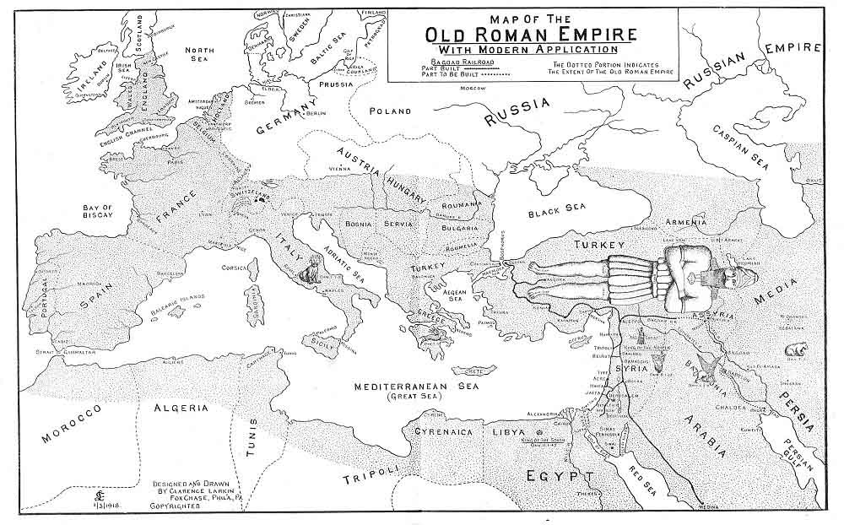
The fact that in her will be found the blood of the Prophets, and Holy Apostles and Saints (verses 20, 24), shows that the Papal Church is not in view in this eighteenth chapter, for there was no Papal Church in Old Testament times, or in the days of the Apostles. It is the ancient as well as the revived City of Babylon that is meant. For in Old Testament days the blood of the Prophets was shed by the "Babylonish System" of false religions as visualized in the City of Babylon. So that it can truthfully be said that the blood of Prophets and Apostles of all ages has been shed by her.

THE EPHAH OF COMMERCE.
There is a remarkable Prophetic Vision recorded by the Prophet Zechariah, that has mystified the Commentators. "Then the Angel that talked with me went forth, and said unto me, Lift up now thine eyes, and see what is this that goeth forth. And I said, What is it? And he said, This is an EPHAH that goeth forth. He said moreover: This is their resemblance through all the earth. And, behold, there was lifted up a 'Talent of Lead': and this is a WOMAN that sitteth in the midst of the EPHAH. And he said, This is WICKEDNESS. And he cast it (her down R. V.) into the midst of the EPHAH: and he cast the weight of lead upon the mouth thereof. Then lifted I up mine eyes, and looked, and, behold, there came out TWO WOMEN, and the wind was in their wings; for they had wings like the wings of a Stork: and they lifted up the EPHAH between the earth, and the heaven. Then said I to the Angel that talketh with me, Whither do these bear the EPHAH? And he said unto me, To build it (her R. V.) an house in the LAND OF SHINAR: and (when it is prepared, she shall be set there in her own place R. V.)." Zech. 5:5-11.
The "EPHAH" which the Prophet saw go forth, is the largest of Hebrew dry measures, and is often used as a symbol of Commerce, and its "resemblance," or going forth through all the earth, doubtless refers to UNIVERSAL COMMERCIALISM. In this "Ephah" sat a "WOMAN" who was called "WICKEDNESS." This "WOMAN" attempted to rise but the Angel thrust her back, and replaced the lid made of a "Talent of Lead." Then "Two Women," with the wings of a Stork, came, and lifted the "Ephah" high in the air and carried it with the swiftness of the wind to the "LAND OF SHINAR" to build it (her R. V.) a HOUSE. Now the "LAND OF SHINAR" was the place where they built the Tower of Babel (Gen. 11:1-9), on whose site ancient BABYLON was located. As this vision of the Prophet occurred many years after the Fall of ancient Babylon, the HOUSE that is to be built for this "Ephah," or the "WOMAN" who was transported in it, must be built in some future City of Babylon.
As we have seen the "Ephah" stands for COMMERCE, and as the occupant of the "Ephah" is called "WICKEDNESS," it reveals the fact that the "Commercialism" of the time of the Vision's fulfilment will be characterized by all manner of dishonest schemes and methods. And the fact that the "WOMAN" is thrust back into the "Ephah" and covered with a "Talent of Lead," indicates that those dishonest schemes and methods are to be kept out of sight. The further fact that the "Ephah" is borne to the "LAND OF SHINAR" by two "Stork Winged Women" is not without significance. The Stork, according to the Mosaic Law, is an unclean bird. The name "Chasid" by which it was known, signified the "PIOUS BIRD," and may well stand for the pursuit of wealth under the guise of religion. That will doubtless be a characteristic of those Babylonian days.
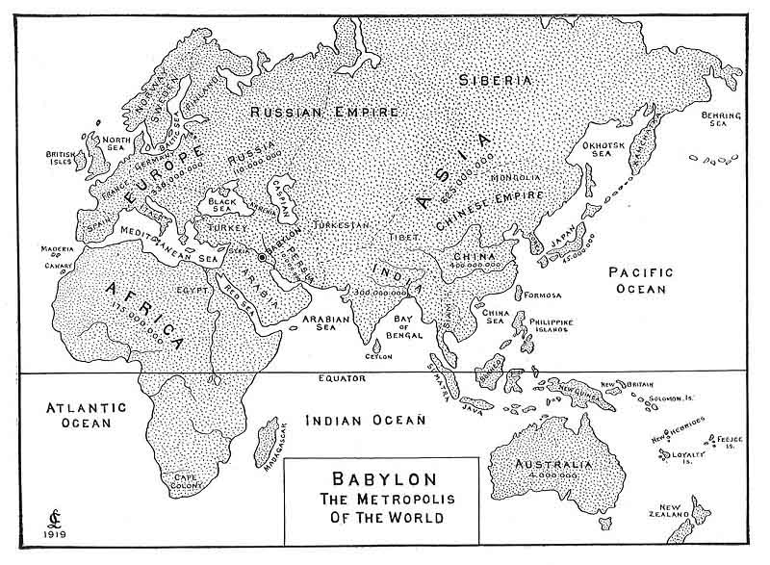
This vision of the "Ephah" by the Prophet Zechariah is still further confirmatory proof that the ancient City of Babylon is to be rebuilt and become the COMMERCIAL CENTRE OF THE WORLD. Every influence political and commercial will favor this, and as the "Stork Winged Women" will be favored by the "wings of the wind," the tendency of Commercialism to that part of the world, when the time comes to carry the "Ephah" to the "Land of Shinar," we can readily see that it will not take long, with the wealth of the world at the command of the Capitalists of that day, to re-build Babylon and make it the great Commercial Centre of the world. Once however Commerce is firmly established in Babylon, the occupant of the "Ephah"--"WICKEDNESS," will lift the lid and reveal herself, and no one will be able to buy or sell but he who has the "MARK OF THE BEAST."
As to the probability of the ancient city of Babylon being rebuilt we have only to consider the events that in recent years have been happening in that part of the world looking to just such a thing.
In the Department of War of France, at Paris, there is to be seen the records of valuable surveys and maps made by order of Napoleon I, in Babylonia, and among them is a plan for a New City of Babylon, thus showing that the vast schemes of Napoleon comprehended the Rebuilding of the Ancient City of Babylon, and the making it his Capital, as his ambition was to conquer the whole of Europe and Asia, and he recognized to that end the strategical position of ancient Babylon as a governmental and commercial centre.
It is a fact that the whole country of Mesopotamia, Assyria and Babylonia, only needs a system of irrigation to make it again the most fertile country in the world, and steps have already been taken in that direction. In 1850 the British Government sent out a military officer with his command to survey and explore the river Euphrates at a cost of $150,000, and when the European war broke out, the great English Engineer who built the Assouam dam in Egypt, was engaged in making surveys in the Euphratean valley for the purpose of constructing a series of irrigation canals that would re-store the country and make it again the great grain producing country it once was. As a result towns and cities would spring up and railroads would be built. What is needed in that part of the world is a "Trans-European-Asiatic-Indian Air Line" that will connect Europe with India, and China. Such a line was the dream of ex-Emperor William of Germany. It was that desire that made him and Abdul Hamid, of Turkey, the closest of political friends, and he secured from Abdul Hamid a concession to build a railway from the Asiatic side of the Bosphorus, by way of Aleppo, to the Tigris river, and from there to Bagdad, and from Bagdad via Babylon (via Babylon, mark that) to Koweit on the Persian Gulf, and most of the road has been built to Bagdad.
With these facts in mind it can readily be seen that it is the purpose of European capitalists to revive the country of Babylonia and rebuild its cities, and when once the time comes the city of Babylon will be rebuilt almost in a night and on a scale of magnificence such as the world has never seen.
The rapid growth of modern cities is one of the remarkable phenomena of the times. Since 1880 more than 500 cities have been built in America. Less than 100 years ago the site of the City of Chicago was but a swampy expanse at the mouth of the Chicago river. Now it has been transformed into a beautiful Metropolis, stretching 25 miles along the shore of Lake Michigan, with 5000 miles of streets, many of them beautiful boulevards 120 feet wide. In 1840 Chicago had only 4470 inhabitants, today the population is over 3,000,000. Once the Capitalists of the world are ready the revived City of Babylon will spring up in a few years.
But I hear a protest. How you say can we be expecting Jesus to come at "any moment," if the city of Babylon must be rebuilt before He can come? There is not a word in Scripture that says that Jesus cannot come and take away His Church until Babylon is rebuilt. The Church may be taken out of the world 25 or even 50 years before that.
Babylon the Great will be an immense city, the greatest in every respect the world has ever seen. It will be a typical city, the London, the Paris, the Berlin, the Petrograd, the New York, the Chicago of its day. It will be the greatest commercial city of the world. Its merchandise will be of gold and silver, and precious stones and pearls, of purple, and silk, and scarlet and costly wools. Its fashionable society will be clothed in the most costly raiment and decked with the most costly jewels. Their homes will be filled with the most costly furniture of precious woods, brass, iron and marble, with the richest of draperies, mats and rugs. They will use the most costly of perfumes, cinnamon, fragrant odors, ointments and frankincense. Their banquets will be supplied with the sweetest of wines, the richest of pastry, and the most delicious of meats. They will have horses and chariots and the swiftest of fast moving vehicles on earth and in the air. They will have their slaves, and they will traffic in the "souls of men." That is women will sell their bodies, and men their souls, to gratify their lusts.
The markets will be crowded with cattle, sheep and horses. The wharves will be piled with goods from all climes. The manufactories will turn out the richest of fabrics, and all that genius can invent for the comfort and convenience of men will be found on the market. It will be a city given over to pleasure and business. Business men and promoters will give their days and nights to scheming how to make money fast, and the pleasure loving will be constantly planning new pleasures. There will be riotous joy and ceaseless feasting. As it was in the days of Noah and of Lot, they will be marrying and giving in marriage, buying and selling, building and planting.
The blood will run hot in their veins. Money will be their god, pleasure their high-priest, and unbridled passion the ritual of their worship.
It will be a city of music. Amid the noise and bustle of its commercial life will be heard the music of its pleasure resorts and theatres. There will be the sound of "harpers and musicians, of pipers and trumpeters" (vs. 22). The world's best singers and players will be there. Its theatres and places of music will be going day and night. In fact there will be no night, for the electric illumination of the city by night will make the night as bright and shadowless as the day, and its stores and places of business will never close, night or day, or Sunday, for the mad whirl of pleasure and the absorbing de-sire for riches will keep the wheels of business constantly moving. And all this will be easy because the "God of this World"--Satan, will possess the minds and bodies of men, for we read in verse 2, that Babylon at that time will be "the Habitation of Devils, and the Hold of Every Foul Spirit, and the Cage of Every Unclean and Hateful Bird." The city will be the seat of the most imposing "OCCULTISM," and mediums, and those desiring to communicate with the other world, will then go to Babylon, as men and women now go to Paris for fashions and sensuous pleasures. In that day demons, disembodied souls, and unclean spirits will find at Babylon the opportunity of their lives to materialize themselves in human bodies, and from the atmospheric heavens above, and from the Abyss below they will come in countless legions until Babylon shall be full of demon possessed men and women, and at the height of its glory, and just before its fall, Babylon will be ruled by SATAN HIMSELF, incarnate in the "Beast"--ANTICHRIST.
But before its destruction God will mercifully deliver His own people, for a voice from heaven will cry--
"Come Out of Her, My People, That Ye be Not Partakers of Her Sins, and that Ye Receive Not of Her Plagues."
As Sodom and Gomorrah could not be destroyed until righteous Lot had escaped, so Babylon cannot be destroyed until all the righteous people in it have fled.
The destruction of the city will be sudden and without warning. A fearful storm will sweep over the city. The lightning and thunder will be incessant. The city will be set on fire and a great Earthquake will shake it from centre to circumference. The tall office buildings, the "Hanging Gardens" and the great towers will totter and fall, the crust of the earth will crack and open, and the whole city with its inhabitants will sink like a "Millstone" (vs. 21), into a lake of burning bitumen, and the smoke will ascend as of a burning fiery furnace, and the horror of the scene will be intensified by vast clouds of steam, generated by the waters of the Euphrates pouring into that lake of fiery asphalt, and when night comes on those clouds of steam will reflect the light of the burning city so it can be seen for miles in all directions in that level country. And the kings of the earth, and the merchants, and the shipmasters, and sailors, and all who have profited by her merchandise, will stand afar off and cry and wail because of her destruction, but the heavens will rejoice for God will have rewarded her Double according to her works, and BABYLON WILL BE NO MORE.

